## **Module 1: Introduction to Tech Futures**

**Module 1: Introduction to Tech Futures**

* **Complete All Items**

*Module In Progress*

* Context Module Sub Header

**This module has 15 videos, 2 polls, 2 discussions, 2 drag-and-drop activities, 1 practice quiz, and 1 assignment. You will need approximately 5-7 hours to complete this module.**

* [Module 1: Introduction and Instructions](https://student.emeritus.org/courses/3412/modules/items/742246)Page

[**Module 1: Introduction and Instructions**](https://student.emeritus.org/courses/3412/modules/items/742246)

ViewedModule item has been viewed and is complete

* [Module 1: Q&A Discussion Board](https://student.emeritus.org/courses/3412/modules/items/742247)Discussion Topic

[**Module 1: Q&A Discussion Board**](https://student.emeritus.org/courses/3412/modules/items/742247)

ContributeMust contribute to this module item to complete it

* [Module 1: Pre-Reading Materials](https://student.emeritus.org/courses/3412/modules/items/742248)Page

[**Module 1: Pre-Reading Materials**](https://student.emeritus.org/courses/3412/modules/items/742248)

ViewedModule item has been viewed and is complete

* [The Fourth Industrial Revolution](https://student.emeritus.org/courses/3412/modules/items/742249)Page

[**The Fourth Industrial Revolution**](https://student.emeritus.org/courses/3412/modules/items/742249)

ViewedModule item has been viewed and is complete

* [Introduction](https://student.emeritus.org/courses/3412/modules/items/742250)Page

[**Introduction**](https://student.emeritus.org/courses/3412/modules/items/742250)

ViewedModule item has been viewed and is complete

* [Program Overview](https://student.emeritus.org/courses/3412/modules/items/742251)Page

[**Program Overview**](https://student.emeritus.org/courses/3412/modules/items/742251)

ViewedModule item has been viewed and is complete

* [Poll 1.1: High-Impact Technologies for the Next Decade](https://student.emeritus.org/courses/3412/modules/items/742252)Page

[**Poll 1.1: High-Impact Technologies for the Next Decade**](https://student.emeritus.org/courses/3412/modules/items/742252)

ViewedModule item has been viewed and is complete

* [Gartner’s Hype Cycle](https://student.emeritus.org/courses/3412/modules/items/742253)Page

[**Gartner’s Hype Cycle**](https://student.emeritus.org/courses/3412/modules/items/742253)

ViewedModule item has been viewed and is complete

* [Drag-and-Drop Activity 1.1: Five Steps of the Gartner’s Hype Cycle](https://student.emeritus.org/courses/3412/modules/items/742254)Assignment

[**Drag-and-Drop Activity 1.1: Five Steps of the Gartner’s Hype Cycle**](https://student.emeritus.org/courses/3412/modules/items/742254)

Sep 16

1 pts

SubmitMust submit this module item to complete it

* [Discussion 1.1: Applying Gartner’s Hype Cycle to Leverage a Technology in Your Organization](https://student.emeritus.org/courses/3412/modules/items/742255)Discussion Topic

[**Discussion 1.1: Applying Gartner’s Hype Cycle to Leverage a Technology in Your Organization**](https://student.emeritus.org/courses/3412/modules/items/742255)

Sep 16

2 pts

ContributeMust contribute to this module item to complete it

* [What is an S-Curve?](https://student.emeritus.org/courses/3412/modules/items/742256)Page

[**What is an S-Curve?**](https://student.emeritus.org/courses/3412/modules/items/742256)

ViewMust view in order to complete this module item

* [Three Phases of the S-Curve](https://student.emeritus.org/courses/3412/modules/items/742257)Page

[**Three Phases of the S-Curve**](https://student.emeritus.org/courses/3412/modules/items/742257)

ViewMust view in order to complete this module item

* [Impact of the S-Curve on Business Strategy](https://student.emeritus.org/courses/3412/modules/items/742258)Page

[**Impact of the S-Curve on Business Strategy**](https://student.emeritus.org/courses/3412/modules/items/742258)

ViewMust view in order to complete this module item

* [Drag-and-Drop Activity 1.2: Strategic Implications Based on S-Curve](https://student.emeritus.org/courses/3412/modules/items/742259)Assignment

[**Drag-and-Drop Activity 1.2: Strategic Implications Based on S-Curve**](https://student.emeritus.org/courses/3412/modules/items/742259)

Sep 16

1 pts

SubmitMust submit this module item to complete it

* [Fly Over of Different Tech Domains](https://student.emeritus.org/courses/3412/modules/items/742260)Page

[**Fly Over of Different Tech Domains**](https://student.emeritus.org/courses/3412/modules/items/742260)

ViewMust view in order to complete this module item

* [Poll 1.2: Most Promising Technology for Your Industry](https://student.emeritus.org/courses/3412/modules/items/742261)Page

[**Poll 1.2: Most Promising Technology for Your Industry**](https://student.emeritus.org/courses/3412/modules/items/742261)

ViewMust view in order to complete this module item

* [Discussion 1.2: Uncovering New Opportunities by Merging Technologies](https://student.emeritus.org/courses/3412/modules/items/742262)Discussion Topic

[**Discussion 1.2: Uncovering New Opportunities by Merging Technologies**](https://student.emeritus.org/courses/3412/modules/items/742262)

Sep 16

2 pts

ContributeMust contribute to this module item to complete it

* [FLP IT Model: Forces and Logic](https://student.emeritus.org/courses/3412/modules/items/742263)Page

[**FLP IT Model: Forces and Logic**](https://student.emeritus.org/courses/3412/modules/items/742263)

ViewMust view in order to complete this module item

* [FLP IT Model: Four Potential Future Scenarios](https://student.emeritus.org/courses/3412/modules/items/742264)Page

[**FLP IT Model: Four Potential Future Scenarios**](https://student.emeritus.org/courses/3412/modules/items/742264)

ViewMust view in order to complete this module item

* [FLP IT Model: Phenomena, Impact, and Triage](https://student.emeritus.org/courses/3412/modules/items/742265)Page

[**FLP IT Model: Phenomena, Impact, and Triage**](https://student.emeritus.org/courses/3412/modules/items/742265)

ViewMust view in order to complete this module item

* [Practice Quiz 1.1: Understanding the FLP IT Model](https://student.emeritus.org/courses/3412/modules/items/742266)Quiz

[**Practice Quiz 1.1: Understanding the FLP IT Model**](https://student.emeritus.org/courses/3412/modules/items/742266)

Sep 16

0 pts

SubmitMust submit this module item to complete it

* [Assignment 1.1: Analyzing the Evolution, Colliding Trends, and Strategic Implications of a Technology](https://student.emeritus.org/courses/3412/modules/items/742267)Assignment

[**Assignment 1.1: Analyzing the Evolution, Colliding Trends, and Strategic Implications of a Technology**](https://student.emeritus.org/courses/3412/modules/items/742267)

Sep 16

4 pts

SubmitMust submit this module item to complete it

* [Getting Ready for Live Session #1: Deep-Dive on Disruption Forces and Logic](https://student.emeritus.org/courses/3412/modules/items/742268)Page

[**Getting Ready for Live Session #1: Deep-Dive on Disruption Forces and Logic**](https://student.emeritus.org/courses/3412/modules/items/742268)

ViewMust view in order to complete this module item

* [Module 1: Additional Resources](https://student.emeritus.org/courses/3412/modules/items/742269)Page

[**Module 1: Additional Resources**](https://student.emeritus.org/courses/3412/modules/items/742269)

ViewMust view in order to complete this module item

* [Module 1: Feedback Survey](https://student.emeritus.org/courses/3412/modules/items/742270)Quiz

[**Module 1: Feedback Survey**](https://student.emeritus.org/courses/3412/modules/items/742270)

Sep 16

SubmitMust submit this module item to complete it

+++++++++++++++++++++++++++++++++++++

Module 1: Introduction and Instructions

Welcome to Module 1. You are embarking on this exciting learning journey about the future of technology. Let’s get started.

One of the most challenging aspects of navigating the future of technology is trying to harness opportunities amid the rush of constant change.

In this module, you will understand what the Fourth Industrial Revolution involves and how technologies emerge.

You will also learn how to improve the performance of technologies by using Gartner’s Hype Cycle and the S-Curve.

Finally, you will have an overview of various technology domains and opportunities that you can capture and apply the FLP-IT model to assess future-oriented tech scenarios and gain a competitive advantage in tech-driven futures.

**Learning Outcomes**

#### **By the end of this module, you will be able to:**

1. Identify the technology with the highest impact for the future.
2. Identify the components of each of the five steps of Gartner’s Hype Cycle.
3. Identify the components of each of the three phases of the S-Curve.
4. Identify the most promising emerging technology for your industry.
5. Evaluate an emerging technology using Gartner's Hype Cycle and describe how to leverage it in your organization.
6. Evaluate the implications of a new product or service created by merging different technologies.
7. Indicate characteristics and components of the FLP IT model.
8. Select and analyze the evolution of a technology using Gartner’s Hype Cycle and the S-Curve, and identify colliding trends and their strategic implications.

**Activities**

Key Activities

Videos 1-15

Drag-and-Drop Activity 1.1: Five Steps of Gartner’s Hype Cycle

Discussion 1.1: Applying Gartner’s Hype Cycle to Leverage a Technology in Your Organization

Drag-and-Drop Activity 1.2: Strategic Implications Based on the S-Curve

Discussion 1.2: Uncovering New Opportunities by Merging Technologies

Assignment 1.1: Analyzing the Evolution, Colliding Trends, and Strategic Implications of a Technology

All the above activities are to be completed by Thursday, September 16, 2021, 4:29 PM UTC.

Self-Study Activities

Reflection 1.1: Colliding Technologies to Integrate the Physical, Digital, and Biological Worlds

Reflection 1.2: Your Learning Goals

Poll 1.1: High-Impact Technologies for the Next Decade

Reflection 1.3: Similarities and Differences Between Gartner’s Hype Cycle and the S-Curve

Reflection 1.4: Challenges in Three Phases of the S-Curve

Poll 1.2: Most Promising Technology for Your Industry

Reflection 1.5: Reflection: Mapping a Different Set of Future Scenarios

Practice Quiz 1.1: Understanding the FLP IT Model

Live Session: Office Hours with your Learning Facilitator(s)

Please note that all Self-Study Activities are optional and do not count toward program completion. You are encouraged to go through these Self-Study Activities to enhance your learning.

**Q&A Discussion Board**

Please use the [**Q&A Discussion Board**](https://student.emeritus.org/courses/3412/discussion_topics/188602)to post your questions and reply to other participants as you engage with the material in this module. Your learning facilitator will moderate this forum and respond to your content-related questions. This discussion board may also assist you in your preparation for office hours. If you have a question you'd like to pose during office hours, please write it in this forum. Please only post questions related to this module's content. We suggest you bookmark this page [delivery to link] and return to it often.

**Need Help? Contact Program Support**

For assistance, click **Support**in the program menu. The Help Center has answers to the most common queries we receive. For further assistance, click **Submit a Request**at the top right of any Help Center page and complete the form. You will receive a prompt response.

Next

# Module 1: Pre-Reading Materials

Before we start the learning journey for this week, here are some optional pre-reading materials that help set the context for this module.

* [Reinvent Your Business Before It’s Too Late  (Links to an external site.)](https://hbr.org/2011/01/reinvent-your-business-before-its-too-late)
* [Solomon’s Code: Humanity in a World of Thinking Machines. Chapter 7.](https://www.amazon.com/Solomons-Code-Humanity-Thinking-Machines/dp/168177870X)

[**Competitive Strategy**](https://hbr.org/topic/competitive-strategy)

# Reinvent Your Business Before It’s Too Late

by

* [Paul Nunes](https://hbr.org/search?term=paul%20nunes)

 and

* [Tim Breene](https://hbr.org/search?term=tim%20breene)

From the Magazine (January–February 2011)

Summary.

To survive over the long haul, a company must reinvent itself periodically, jumping from the flattening end of one business performance curve to the rising slope of another. Very few companies make the leap successfully when the time comes. That’s because they start the reinvention process too late.

Once existing business begins to stall and revenue growth drops significantly, a company has less than a 10% chance of ever fully recovering.

Accenture’s Nunes and Breene, reporting on the results of their long-running High Performance Business research program, point to a striking difference between companies that have successfully reinvented themselves and those that failed. High performers manage their businesses not just along the growth curve of their revenues but also along three much shorter, though equally important, S curves: tracking the basis of competition in their industry, renewing their capabilities, and nurturing a ready supply of talent.

By planting the seeds for new businesses before revenues from existing ones begin to stall, these companies enjoy sustained high performance. Close

Sooner or later, all businesses, even the most successful, run out of room to grow. Faced with this unpleasant reality, they are compelled to reinvent themselves periodically. The ability to pull off this difficult feat—to jump from the maturity stage of one business to the growth stage of the next—is what separates high performers from those whose time at the top is all too brief.

The potential consequences are dire for any organization that fails to reinvent itself in time. As Matthew S. Olson and Derek van Bever demonstrate in their book [*Stall Points,*](http://yalepress.yale.edu/yupbooks/book.asp?isbn=9780300158519) once a company runs up against a major stall in its growth, it has less than a 10% chance of ever fully recovering. Those odds are certainly daunting, and they do much to explain why two-thirds of stalled companies are later acquired, taken private, or forced into bankruptcy.

There’s no shortage of explanations for this stalling—from failure to stick with the core (or sticking with it for too long) to problems with execution, misreading of consumer tastes, or an unhealthy focus on scale for scale’s sake. What those theories have in common is the notion that stalling results from a failure to fix what is clearly broken in a company.

Having spent the better part of a decade researching the nature of high performance in business, we realized that those explanations missed something crucial. Companies fail to reinvent themselves not necessarily because they are bad at fixing what’s broken, but because they wait much too long before repairing the deteriorating bulwarks of the company. That is, they invest most of their energy managing to the contours of their existing operations—the financial S curve in which sales of a successful new offering build slowly, then ascend rapidly, and finally taper off—and not nearly enough energy creating the foundations of successful new businesses. Because of that, they are left scrambling when their core markets begin to stagnate.

#### About the Research

At Accenture, we have been conducting the High Performance Business research program since 2003. Starting ...

At Accenture, we have been conducting the High Performance Business research program since 2003. Starting from the premise that all performance is relative, we examined sets of peer companies. Previous research on high performance had compared companies head-to-head across industries, but that approach ignored the differences in average profitability, maturity, and risk from one industry to another, making it a contest among industries rather than among companies.

We settled on 31 peer sets for our initial study, encompassing more than 800 companies and representing more than 80% of the market capitalization of the Russell 3000 Index at the time. We analyzed performance in terms of 13 financial metrics to assess growth, profitability, consistency, longevity, and positioning for the future. In most cases, we applied the metrics over a 10-year span.

The businesses that performed extraordinarily well over the long term had all made regular transitions from maturing markets to new, vibrant ones. To find out how these organizations were able to maintain a high level of performance, we conducted years of follow-on investigation, creating special teams from our industry and business-function practice areas. Team members’ expertise and experience was supplemented by contributions from independent researchers and scholars.

Today, the program includes regional and global studies of high performance, to take into account the explosive success of many emerging-market companies.

In our research, we’ve found that the companies that successfully reinvent themselves have one trait in common. They tend to broaden their focus beyond the financial S curve and manage to three much shorter but vitally important hidden S curves—tracking the basis of competition in their industry, renewing their capabilities, and nurturing a ready supply of talent. In essence, they turn conventional wisdom on its head and learn to focus on fixing what doesn’t yet appear to be broken.

## Thrown a Curve

Making a commitment to reinvention before the need is glaringly obvious doesn’t come naturally. Things often look rosiest just before a company heads into decline: Revenues from the current business model are surging, profits are robust, and the company stock commands a hefty premium. But that’s exactly when managers need to take action.

#### Jumping the S Curve

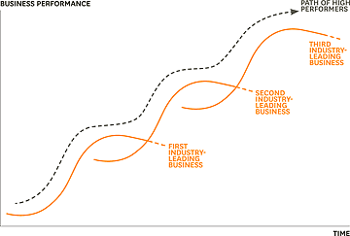

High performers are well on their way to new-business success by the time their existing businesses start to ...

To position themselves to jump to the next business S curve, they need to focus on the following.

### The hidden competition curve.

Long before a successful business hits its revenue peak, the basis of competition on which it was founded expires. Competition in the cell phone industry, for instance, has changed several times—for both manufacturers and service providers—from price to network coverage to the value of services to design, branding, and applications. The first hidden S curve tracks how competition in an industry is shifting. High performers see changes in customer needs and create the next basis of competition in their industry, even as they exploit existing businesses that have not yet peaked.

Netflix, for example, radically altered the basis of competition in DVD rentals by introducing a business model that used delivery by mail. At the same time, it almost immediately set out to reinvent itself by capturing the technology that would replace physical copies of films—digital streaming over the internet. Today Netflix is the largest provider of DVDs by mail and a major player in online streaming. In contrast, Blockbuster rode its successful superstore model all the way to the top, tweaking it along the way (no more late fees) but failing to respond quickly enough to changes in the basis of competition.

### The hidden capabilities curve.

In building the offerings that enable them to climb the financial S curve, high performers invariably create distinctive capabilities. Prominent examples include Dell with its direct model of PC sales, Wal-Mart with its unique supply chain capabilities, and Toyota with not just its production method but also its engineering capabilities, which made possible Lexus’s luxury cars and the Prius. But distinctiveness in capabilities—like the basis of competition—is fleeting, so executives must invest in developing new ones in order to jump to the next capabilities S curve. All too often, though, the end of the capabilities curve does not become apparent to executives until time to develop a new one has run out.

**Book**

24.95[View Details](https://hbr.org/2011/01/reinvent-your-business-before-its-too-late)

Take the music industry. The major players concentrated on refining current operations; it was a PC maker that developed the capabilities needed to deliver digital music to millions of consumers at an acceptable price. High performers are continually looking for ways to reinvent themselves and their market. P&G long ago recognized the untapped customer market for disposable diapers. The company spent five years perfecting the capabilities that would allow diapers to be priced similarly to what customers were then paying services to launder and deliver cloth diapers. Amazon.com CEO Jeff Bezos notes that it takes five to seven years before the seeds his company plants—things like expanding beyond media products, working with third-party sellers, and going international—grow enough to have a meaningful impact on the economics of the business; this process requires foresight, early commitment, and tenacious faith in the power of R&D.

### The hidden talent curve.

Companies often lose focus on developing and retaining enough of what we call serious talent—people with both the capabilities and the will to drive new business growth. This is especially true when the business is successfully humming along but has not yet peaked. In such circumstances, companies feel that operations can be leaner (they’ve moved far down the learning curve by then) and meaner, because they’re under pressures to boost margins. They reduce both head count and investments in talent, which has the perverse effect of driving away the very people they could rely on to help them reinvent the business.

**High performance companies need up-and-comers who can grow a new business, not just manage an old one.**

The high performers in our study maintain a steady commitment to talent creation. The oil-field services provider Schlumberger is always searching for and developing serious talent, assigning “ambassadors” to dozens of top engineering schools around the world. These ambassadors include high-level executives who manage large budgets and can approve equipment donations and research funding at those universities. Close ties with the schools help Schlumberger get preference when it is recruiting. Not only does Schlumberger keep its talent pipeline flowing, but it’s a leader in employee development. In fact, it is a net producer of talent for its industry, a hallmark of high performers.

#### The Hidden S Curves of High Performance

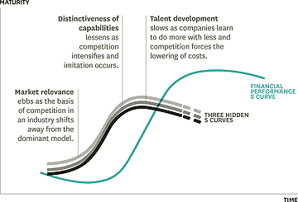

Three aspects of a business mature—and start to decline—much faster than financial performance does. They need ...

Three aspects of a business mature—and start to decline—much faster than financial performance does. They need to be reinvented before you can grow a new business.

By managing to these hidden curves—as well as keeping focused on the revenue growth S curve, it must be emphasized—the high performers in our study had typically started the reinvention process well before their current businesses had begun to slow. So what are the management practices that prepare high performers for reinvention? Let’s look first at the response to the hidden competition curve.

## Edge-Centric Strategy

Traditional strategic-planning methods are useful in stretching the revenue S curve of an existing business, but they can’t help companies detect how the basis for competition in a market will change.

To make reinvention possible, companies must supplement their traditional approaches with a parallel strategy process that brings the edges of the market and the edges of the organization to the center. In this “edge-centric” approach, strategy making becomes a permanent activity without permanent structures or processes.

### Moving the edge of the market to the center.

An edge-centric strategy allows companies to continually scan the periphery of the market for untapped customer needs or unsolved problems. Consider how Novo Nordisk gets to the edge of the market to detect changes in the basis of competition as they’re occurring. For example, through one critical initiative the pharma giant came to understand that its future businesses would have to address much more than physical health. The initiative—[Diabetes Attitudes, Wishes, and Needs (DAWN)](http://www.novonordisk.com/about_us/changing-diabetes-activities/dawn.asp)—brings together thousands of primary care physicians, nurses, medical specialists, patients, and delegates from major associations like the World Health Organization to put the individual—rather than the disease—at the center of diabetes care.

Research conducted through DAWN has opened Novo’s eyes to the psychological and sociological needs of patients. For example, the company learned that more than 40% of people with diabetes also have psychological issues, and about 15% suffer from depression. Because of such insights, the company has begun to reinvent itself early; it focuses less on drug development and manufacturing and more on disease prevention and treatment, betting that the future of the company lies in concentrating on the person as well as the disease.

### Moving the edge of the organization to the center.

Frontline employees, far-flung research teams, line managers—all these individuals have a vital role to play in detecting important shifts in the market. High performers find ways to bring these voices into the strategy-making process. Best Buy listens to store managers far from corporate headquarters, such as the New York City manager who created a magnet store for Portuguese visitors coming off cruise ships. Reckitt Benckiser got one of its most successful product ideas, Air Wick Freshmatic, from a brand manager in Korea. The idea was initially met with considerable internal skepticism because it would require the company to incorporate electronics for the first time—but CEO Bart Becht is more impressed by passion than by consensus.

If strategy making is to remain on the edge, it cannot be formalized. We found that although low and average performers tend to make strategy according to the calendar, high performers use many methods and keep the timing dynamic to avoid predictability and to prevent the system from being gamed.

As quickly as competition shifts, the distinctiveness of capabilities may evaporate even faster. By the time a business really takes off, imitators have usually had time to plan and begin their attack, and others, attracted to marketplace success, are sure to follow. How, then, do companies build the capabilities necessary to jump to a new financial S curve?

## Change at the Top

Some executives excel at running a business—ramping up manufacturing, expanding into different geographies, or extending a product line. Others are entrepreneurial—their strength is in creating new markets. Neither is inherently better; what matters is that the capabilities of the top team match the firm’s organizational needs on the capabilities S curve. Companies run into trouble when their top teams stay in place to manage the financial S curve rather than evolve to build the next set of distinctive capabilities.

**Jumping the S curve requires frequent injections of new blood and a continual shake-up of the top team.**

Avoiding that trap runs counter to human nature, of course. What member of a top team wants to leave when business is good? High performers recognize that a key to building the capabilities necessary to jump to a new financial S curve is the early injection of new leadership blood and a continual shake-up of the top team.

### Early top-team renewal.

Consider how the top team at Intel has evolved. Throughout its history, the semiconductor manufacturer has seen its CEO mantle rest on five executives: Robert Noyce, Gordon Moore, Andy Grove, Craig Barrett, and current CEO Paul Otellini. Not once has the company had to look outside to find this talent, and the transitions have typically been orderly and well orchestrated. “We discuss executive changes 10 years out to identify gaps,” explains David Yoffie, who has served on the Intel board since 1989.

Simple continuity is not Intel’s goal in making changes at the top, however; evolving the business is. For instance, when Grove stepped down from the top spot, in 1998, he was still a highly effective leader. If continuity had been Intel’s overwhelming concern, Grove might have stayed for another three years, until he reached the mandatory retirement age of 65. But instead, he handed the baton to Barrett, who then implemented a strategy for growing Intel’s business through product extensions.

Indeed, each of Intel’s CEOs has left his mark in a different way. Grove made the bold decision to move Intel away from memory chips in order to focus on microprocessors, a transition that established the company as a global high-tech leader. Since he took the helm, in 2005, Otellini has focused on the Atom mobile chip, which is being developed for use in just about any device that might need to connect to the web, including cell phones, navigation systems, and even sewing machines (for downloading patterns).

Through structured succession planning, Intel ensures that it chooses the CEO who is right for the challenges the company is facing, not simply the person next in line. And by changing CEOs early, the company gives its new leadership time to produce the reinvention needed, well before deteriorating revenues and dwindling options become a crisis.

### Balance short-term and long-term thinking.

Ensuring that the team is balanced with a focus on both the present and the future is another critical step in developing a new capabilities curve. When Adobe bought Macromedia in 2005, then-CEO Bruce Chizen took a hard look at his senior managers to determine which of them had what it took to grow the company to annual revenues of $10 billion. What he found was a number of executives who lacked either the skills or the motivation to do what was necessary. Consequently, Chizen tapped more executives from Macromedia than from Adobe for key roles in the new organization. Those choices were based on Adobe’s future needs, not on which executives were the most capable at the time.

Chizen wasn’t tough-minded just with others. At the relatively young age of 52, and only seven years into his successful tenure, he handed over the reins to Shantanu Narayen, his longtime deputy. The timing might have seemed odd, but it made good sense for Adobe: The company faced a new set of challenges—and the need for new capabilities—as it anticipated going head-to-head against larger competitors like Microsoft.

In other cases, the executive team might need to gather fresh viewpoints from within the organization to balance long-established management thinking. Before Ratan Tata took over at India’s Tata Group, in 1991, executives had comfortably ruled their fiefdoms for ages and rarely retired. But the new chairman began easing out those complacent executives (not surprisingly, some of their departures were acrimonious) and instituted a compulsory retirement age to help prevent the future stagnation of his senior leadership. The dramatic change opened dozens of opportunities for rising in-house talent who have helped Tata become India’s largest private corporate group.

### Organize to avoid overload.

Finally, high performers organize their top teams so that responsibilities are more effectively divided and conquered. Three critical tasks of senior leadership are information sharing, consulting on important decisions, and making those decisions. Although many companies have one group that performs all three functions, this can easily become unwieldy.

An alternative approach, which we observed in many high performers, is to split those tasks—in effect, creating teams nested within teams. At the very top are the primary decision makers—a group of perhaps three to seven people. This group then receives advice from other teams, so hundreds of people may be providing important input.

## Surplus Talent

Business reinvention requires not just nimble top teams but also large numbers of people ready to take on the considerable challenge of getting new businesses off the ground and making them thrive. High performers take an approach that is, in its way, as difficult as changing out top leadership before the company’s main business has crested: They create much more talent than they need to run the current business effectively—particularly talent of the kind that can start and grow a business, not just manage one. This can be a hard sell in the best of times, which is probably why so many avoid it.

**One sign that a company is investing enough in talent: Employees have time to think on the job.**

One of the signs that a company has surplus talent is that employees have time to think on the job. Many of our high performers make time to explore a regular component of their employees’ workweek. (Think Google and 3M.) Another is a deep bench—one that allows promising managers to take on developmental assignments and not just get plugged in where there is an urgent need. High performance companies aggressively search out the right type of candidate and then take action to strengthen individuals for the challenges ahead.

### Hire for cultural fit.

High performance companies begin with the expectation that they are hiring people for the long term—a perspective that fundamentally alters the nature of their hiring and development practices. They don’t just look for the best people for the current openings; they recognize that cultural fit is what helps ensure that someone will perform exceptionally well over time.

One company that gets this right is the Four Seasons Hotels and Resorts. It specifically looks for people who will thrive in a business that treats customers like kings—because, quite literally, some guests could be. “I can teach anyone to be a waiter,” says Isadore Sharp, CEO of the luxury hotel chain in his book [*Four Seasons: The Story of a Business Philosophy*](http://us.penguingroup.com/nf/Book/BookDisplay/0,,9781591842446,00.html?Four_Seasons_Isadore_Sharp). “But you can’t change an ingrained poor attitude. We look for people who say, ‘I’d be proud to be a doorman.’”

Reckitt Benckiser also puts cultural fit at the top of its hiring priorities. Before candidates begin the application process, they can complete an online simulation that determines whether they are likely to be a good match with the firm’s exceptionally driven culture. The candidates are presented with business scenarios and asked how they would respond. After reviewing their “fit” score, they can decide for themselves whether they want to continue pursuing employment with the company.

### Prepare for challenges ahead.

Making sure that new employees are fit to successfully navigate the tough stretches in a long career requires something we call stressing for strength. At low-performer companies, employees may find themselves wilting when faced with unexpected or harsh terrain. High performers create environments—often challenging ones—in which employees acquire the skills and experience they will need to start the company’s next S curve. The goal is partly to create what our Accenture colleague Bob Thomas, in his book on the topic, calls “crucible” experiences. These are life-changing events, whether on the job or not, whose lessons help transform someone into a leader.

Crucible experiences can—and should—be created intentionally. When Jeff Immelt was still in his early 30s and relatively new in his career at GE, he was tapped by then-CEO Jack Welch and HR chief Bill Conaty to deal with the problem of millions of faulty refrigerator compressors—despite his lack of familiarity with appliances or recalls. Immelt later said he would never have become CEO without that trial-by-fire experience.

### Give employees room to grow.

After choosing and testing the right employees, companies must give them a chance to develop. To truly enable them to excel in their work, companies should take a hard look at exactly what people are required to do day by day.

UPS has long known that its truck drivers are crucial to its success. Experienced drivers know the fastest routes, taking into account the time of day, the weather, and various other factors. But the turnover rate for drivers was high, partly because of the hard physical labor required to load packages onto the trucks. So UPS separated out that task and gave it to part-time workers, who were more affordable and easier to find, allowing a valuable group of employees to concentrate on their capabilities and excel at their jobs.

Companies can also use organizational structure to provide employees with ample opportunities to grow. Illinois Tool Works, a global manufacturer of industrial products and equipment, is organized into more than 800 business units. Whenever one of those units becomes too large (the maximum size is around $50 million in sales), ITW splits that business, thus opening up managerial positions for young talent. In fact, it’s not uncommon for ITW managers to start running a business while they’re still in their 20s.

And high performance businesses aren’t afraid to leapfrog talented employees over those with longer tenure. After A.G. Lafley took over at P&G, for example, he needed someone to run the North American baby-care division, which was struggling. Instead of choosing one of the 78 general managers with seniority, he reached lower in the organization and tapped Deborah Henretta. Lafley’s move paid off. Henretta reversed 20 years’ worth of losses in the division and was later promoted to group president of Asia, overseeing a $4 billion-plus operation.

Breaking the mold in one way or another—as leaders have done at UPS, ITW, and P&G—is critical to building surplus talent in the organization. It not only keeps key individuals (or groups, in the case of UPS’s drivers) on board; it also signals to the organization as a whole that no compromises on talent will be made in order to achieve short-sighted cost savings.

Even top organizations are vulnerable to slowdowns. In fact, an economic downturn can exacerbate problems for companies already nearing the end of their financial S curve. (See the sidebar “Why Now?”) Even in the best of times, business crises—whether they are caused by hungry new competitors, transformational technology, or simply the aging of an industry or a company—come with regularity. Companies in other industries may be feeling great, while your business (or industry) faces its own great depression.

#### Why Now?

Why do economic slowdowns call for innovation and reinvention? Reduced sales and increased discounting tend ...

#### Why Now?

Why do economic slowdowns call for innovation and reinvention? Reduced sales and increased discounting tend to squash companies’ revenue S curves. Worse, the S curves do not stretch back out as conditions improve. Companies lose ground in four key areas:

### Intellectual Property

Patent offices don’t put years back on the clock just because a company’s sales tapered off in a bad economy. This can have a devastating effect on, for instance, pharmaceuticals, where generics constantly challenge proprietary drugs as patents expire.

### Technology

Economic downturns can slow the introduction of new technologies, but not for long. Witness the fate of some manufacturers of plasma televisions, which have been forced to exit the business under the double whammy of the downturn and steady improvements in LCD and LED sets.

### Competition

Companies looking to grow sales in a recession must take market share from competitors. As they press advantage, already weakened companies face possible extinction. In the movie-viewing market, for instance, companies that dominate newer channels have driven bricks-and-mortar retailers into bankruptcy.

### Consumer Tastes

Novelty wears off, regardless of the economy. Even though they’ve bought less during the downturn, consumers accustomed to the idea of “fast fashion,” for example, will not be interested in last year’s styles.

In the face of all these challenges, companies that manage themselves according to the three hidden S curves—the basis of competition, the distinctiveness of their capabilities, and a ready supply of talent—will be in a much better position to reinvent themselves, jumping to the next S curve with relative ease. Those that do not are likely to respond to a stall in growth by creating an urgent and drastic reinvention program—with little likelihood of success.

A version of this article appeared in the [January–February 2011](https://hbr.org/archive-toc/BR1101) issue of Harvard Business Review.

* [**Paul Nunes**](https://hbr.org/search?term=paul%20nunes&search_type=search-all) is the global managing director of thought leadership at Accenture Research and a coauthor of [*Big Bang Disruption: Strategy in the Age of Devastating Innovation*](http://www.amazon.com/Big-Bang-Disruption-Devastating-Innovation/dp/1591846900/ref=sr_1_1?ie=UTF8&qid=1404224904&sr=8-1&keywords=big+bang+disruption) and [*Jumping the S-Curve: How to Beat the Growth Cycle, Get on Top, and Stay There*](http://www.amazon.com/dp/B004JF5YQW/ref=rdr_kindle_ext_tmb) (Portfolio, 2014).
* TB

Tim Breene is the CEO of Accenture Interactive, the company’s digital marketing initiative. They are the authors of [Jumping the S-Curve: How to Beat the Growth Cycle, Get on Top, and Stay There](http://hbr.org/product/jumping-the-s-curve-how-to-beat-the-growth-cycle-g/an/12149-HBK-ENG?Ntt=Jumping%2520the%2520S-Curve%253A%2520How%2520to%2520Beat%2520the%2520Growth%2520Cycle%252C%2520Get%2520on%2520Top%252C%2520and%2520Stay%2520There) (Harvard Business Review Press, 2011), from which this article is adapted.

Next

# The Fourth Industrial Revolution

**Video 1 (04:32) - The Fourth Industrial Revolution**

In this video, Professor Olaf Groth shares some exciting advancements in the Fourth Industrial Revolution, how it is different from former industrial revolutions, and what new opportunities to expect in the future.

 Reflection: Colliding Technologies to Integrate the Physical, Digital, and Biological Worlds

Reflections are small points of reflection between module topics and encourage you to take a moment to synthesize what you have learned and how it can be applied to your life. These reflections are not required, are ungraded, and contain no deliverables. They are questions for you to consider as you work through the program content.

In Video 1, Professor Olaf Groth mentioned the importance of colliding different technologies such as Artificial Intelligence (AI) with brain-computer interfaces. Reflect on the various technologies that you encounter in your personal and professional life. In what ways could they collide with one another, and what are some new opportunities that can emerge?

Next

# Introduction

**Video 2 (03:29) - Introduction**

In this video, Professor Olaf Groth introduces himself and shares the learning objectives for this program.

# Program Overview

**Video 3 (05:17) - Program Overview**

Wondering what you will learn from each module of the program? In this video, Professor Olaf Groth gives an overview of the key topics that will be covered in each of the eight modules

**Reflection: Your Learning Goals**

In Video 2, Professor Olaf Groth introduced the learning objectives for this program. What are your learning goals for this program? What new knowledge, skills, and mindsets do you hope to gain from this program? How would you measure the success of your learning outcomes?

Next

# Poll 1.1: High-Impact Technologies for the Next Decade

In Video 3, Professor Olaf Groth mentioned some technologies to be covered in this program. Reflect on your current understanding of these technologies and how they may evolve in the future. Which technology do you think will have the highest impact in the next decade?

Please select the option that you believe best answers the question. After you have submitted your answer, you will be able to see your peers’ responses. Then take a look at the poll results, and think about why certain technologies are chosen more than others.

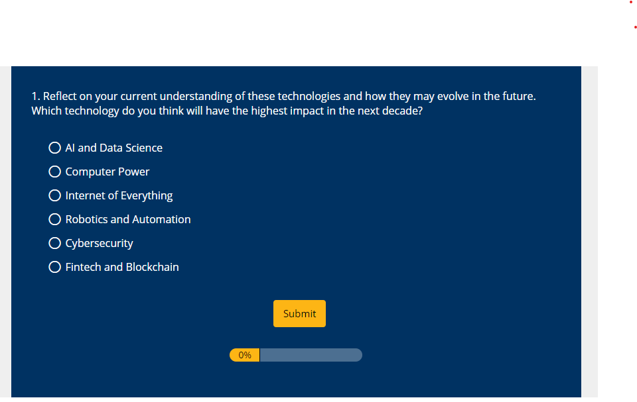

Next

# Gartner’s Hype Cycle

Innovations, particularly technology innovations, go through a recognizable pattern, often referred to as Gartner’s Hype Cycle. In the next two videos, Professor Olaf Groth introduces what Gartner’s Hype Cycle is and what it means to organizations looking to adopt new technologies.

**Video 4 (05:39) - Gartner's Hype Cycle (Part A)**

In this video, Professor Olaf Groth introduces the different steps that are part of Gartner’s Hype Cycle.

**Video 5 (05:36) - Gartner's Hype Cycle (Part B)**

In this video, Professor Olaf Groth shares how Gartner’s Hype Cycle has evolved over the recent years, and how organizations can leverage it to make strategic decisions.

**Deep Dive: Opportunities for Each Step of the Hype Cycle**

In the last two videos, you learned about the different steps of the Hype Cycle. At each step of the hype cycle, certain decisions can help adopt the technology effectively when the time is right for your specific use case and business requirements. The table below shares opportunities you can explore to better advance the adoption efforts in the right direction.

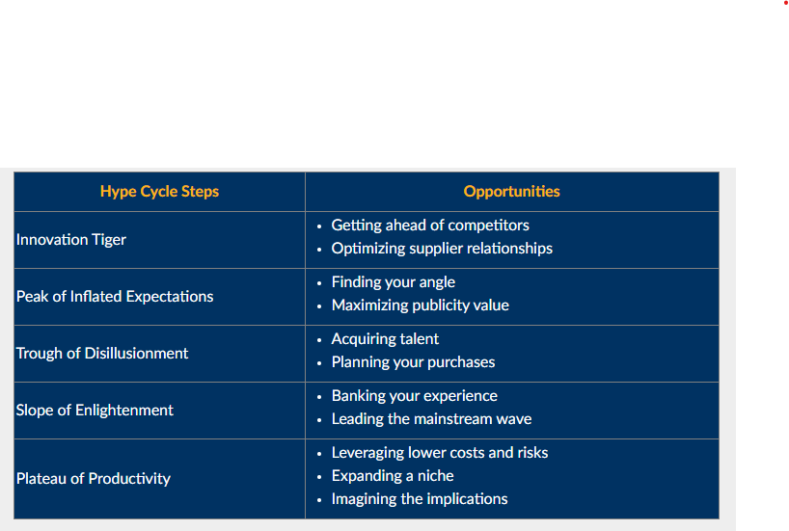

[Understanding Gartner’s Hype Cycles | Gartner](https://www.gartner.com/en/documents/3887767)

# Understanding Gartner’s Hype Cycles

##### **Summary**

Hype Cycles and Priority Matrices offer a snapshot of the relative market promotion and perceived value of innovations. They highlight overhyped areas, estimate when innovations and trends will reach maturity, and provide actionable advice to help organizations decide when to adopt.

Published: 20 August 2018

ID: G00370163

Analyst(s): [Marcus Blosch](https://www.gartner.com/en/experts/marcus-blosch) ,  [Jackie Fenn](https://www.gartner.com/en/experts/jackie-fenn)

#### **Overview**

##### **Key Findings**

Hype Cycles:

* Establish the expectation that most innovations, services and disciplines will progress through a pattern of overenthusiasm and disillusionment, followed by eventual productivity.
* Provide a snapshot of the relative market promotion, maturity and value of innovations within a certain segment, such as a technology area, horizontal or vertical business market, or a demographic audience.
* Show the speed at which each innovation is progressing through the Hype Cycle by indicating how long it will take to reach the Plateau of Productivity and the start of mainstream adoption.
* Help strategists and planners by evaluating the market promotion and perception of value, business benefit, adoption rate and future direction of innovations.

##### **Recommendations**

IT leaders building a world-class EA discipline or exploring trends and innovations for the opportunities they can provide should:

* Avoid investing in an innovation just because it is being hyped. And do not ignore it just because it is not living up to early overexpectations — that is, it’s in the Trough of Disillusionment.
* Be selectively aggressive and move early with innovations that are potentially beneficial to your business. Let others learn the hard lessons of innovations that are of lower impact, delaying your adoption until the innovation is more mature.
* Use the Priority Matrix that accompanies each Hype Cycle to evaluate the potential benefit of each innovation and determine investment priorities.

#### **Analysis**

##### **What Is the Hype Cycle?**

The Hype Cycle is a graphical depiction of a common pattern that arises with each new technology or other innovation. Although many of Gartner’s Hype Cycles focus on specific technologies or innovations, the same pattern of hype and disillusionment applies to higher-level concepts such as IT methodologies and management disciplines. In this document, we refer to the individual elements mapped on the Hype Cycles as “innovation profiles.” But in many cases, the Hype Cycles also position higher-level trends and ideas, such as strategies, standards, management concepts, competencies and capabilities.

Each year, Gartner creates more than 100 Hype Cycles in various domains to enable clients to track innovation maturity and future potential ([click here](https://www.gartner.com/explore/hypecycles) for the complete list of our 2018 Hype Cycles). This document is a companion to Gartner’s Hype Cycles. It explains:

* Why Hype Cycles are important for organizations deciding which new innovations to adopt and when
* How Gartner determines the positioning of innovation profiles on the Hype Cycles
* What actions strategy and technology planners should take based on knowledge of Gartner’s Hype Cycles

Hype Cycles characterize the typical progression of innovation, from overenthusiasm through a period of disillusionment to an eventual understanding of the innovation’s relevance and role in a market or domain (see Figure 1).

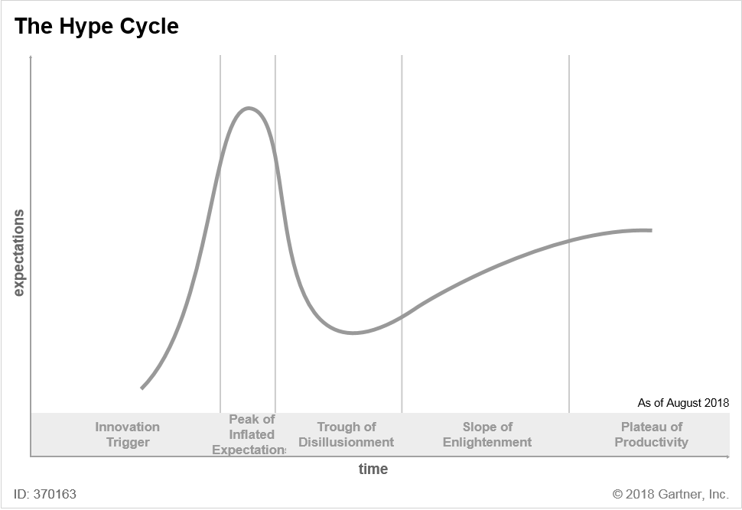

A technology (or related service and discipline innovation) passes through several stages on its path to productivity:

* **Innovation Trigger (formerly called Technology Trigger):** The Hype Cycle starts when a breakthrough, public demonstration, product launch or other event generates press and industry interest in a technology innovation.
* **Peak of Inflated Expectations:** A wave of “buzz” builds and the expectations for this innovation rise above the current reality of its capabilities. In some cases, an investment bubble forms, as happened with the web and social media.
* **Trough of Disillusionment:** Inevitably, impatience for results begins to replace the original excitement about potential value. Problems with performance, slower-than-expected adoption or a failure to deliver financial returns in the time anticipated all lead to missed expectations, and disillusionment sets in.
* **Slope of Enlightenment:** Some early adopters overcome the initial hurdles, begin to experience benefits and recommit efforts to move forward. Organizations draw on the experience of the early adopters. Their understanding grows about where and how the innovation can be used to good effect and, just as importantly, where it brings little or no value.
* **Plateau of Productivity:** With the real-world benefits of the innovation demonstrated and accepted, growing numbers of organizations feel comfortable with the now greatly reduced levels of risk. A sharp rise in adoption begins (resembling a hockey stick when shown graphically), and penetration accelerates rapidly as a result of productive and useful value.

See Figure 2 for an example of a Hype Cycle.

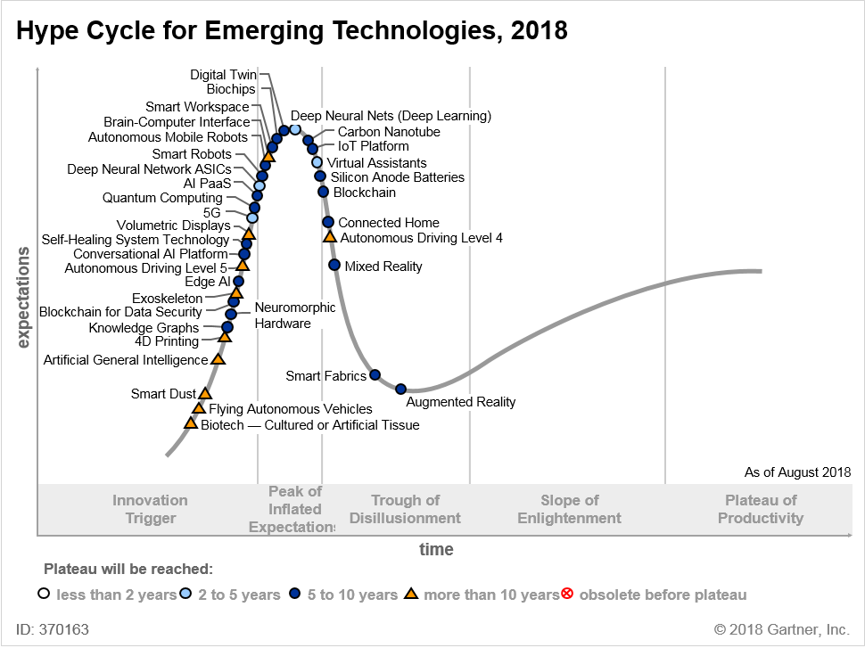

The horizontal axis of the Hype Cycle is labeled “time.” This is because a single innovation will progress through each stage as time passes. In practice, most Gartner Hype Cycles are a snapshot showing the relative positions of a set of innovation profiles at a single point in time. However, single-topic Hype Cycles can be useful for predicting the future path of an innovation. One notable example was the e-business Hype Cycle published in 1999, which accurately predicted the dot-com bust of 2001 and the eventual emergence of e-business as “business as usual.”

The vertical axis is labeled “expectations.” The distinctive vertical shape of the Hype Cycle curve shows how expectations surge and contract over time as an innovation progresses, based on the marketplace’s assessment of its future expected value. Originally, the vertical axis was labeled “visibility,” but we changed this in 2009. The original label focused on the level of buzz and market discourse that drives the peak. The current label more accurately reflects the deeper root cause and nature of the buzz as the innovation progresses. For example, an innovation may be in the trough yet still visible in the form of negative press. In particular, the current label highlights the changing views of potential and actual adopters of the innovation, and the shifting pressures surrounding investment decisions.

The Hype Cycle shows two stages of upward direction (that is, increasing expectations):

* The rise up to the Peak of Inflated Expectations
* The rise up to the Slope of Enlightenment

The first rise is due to the excitement about the new opportunities the innovation will bring, driven mostly by market hype. Excitement occurs in a rush, rises to a peak and dies down when early expectations are not met rapidly enough (see the first curve in Figure 3). The reason that expectations are not met is that the innovation’s maturity is usually still low when excitement is peaking (see the second and third curves in Figure 3). High expectations and low maturity lead to the drop into the Trough of Disillusionment. The second rise of increasing expectations is driven by the increase in maturity of the innovation, which leads to real value and fulfilled expectations.

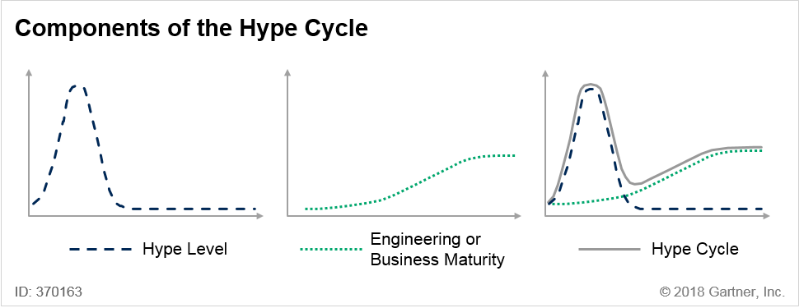

The vertical scale of each innovation’s hype curve typically varies, based on the innovation’s overall perceived importance to business and society. For visualization purposes, we have normalized the scale of these individual hype curves so they all fit in one Hype Cycle graphic.

For example, mesh networks are an interesting method of using peer-to-peer wireless networking bandwidth. But they are relevant mainly to wireless network service providers, thus reaching a relatively low degree of overall expectation and hype. Other innovation profiles that appeal to a large number of companies (for example, cloud computing) or consumers (for example, media tablets) attain much higher levels of exposure and hype. Therefore, even when mesh networking is at the peak of its hype curve, it may still receive less overall “hype volume” than cloud computing or media tablets.

The Hype Cycle ends at the start of the Plateau of Productivity, where mainstream adoption of the innovation surges. As with the height of the Peak of Inflated Expectations, the final height of the Plateau of Productivity varies. Its height reflects whether the innovation is broadly applicable and highly visible, or benefits only a niche market. For a model that tracks innovation profiles through their entire life cycle until they can no longer be viably used or exploited, see

Innovation profiles do not move at a uniform speed through the Hype Cycle. We assign each innovation on the Hype Cycle to a category that represents how long it will take to reach the Plateau of Productivity from its current position. In other words, we assign it to a category that shows how long the innovation is from the start of mainstream adoption. The categories are:

* Less than two years
* Two to five years
* Five to 10 years
* More than 10 years
* Obsolete before plateau (that is, the innovation will never reach the plateau, as it will fail in the market or be overtaken by competing solutions)

##### **Positioning an Innovation on the Hype Cycle**

We position innovation profiles on the Hype Cycle based on a consensus assessment of hype and maturity. We select a variety of market signals and proxy indicators to establish the level of expectations. Some of these inputs may be quantitative but, overall, the Hype Cycle is a structured, qualitative research tool. During the first part of the Hype Cycle, many uncertainties exist regarding an innovation. At this stage, its position on the curve is guided more by its hype levels and market expectation than by its maturity. At the later stages, as more information about maturity, performance and adoption becomes available, hype plays a lesser role in determining the innovation’s position on the Hype Cycle.

An innovation may have radically different positions on different Hype Cycles. This occurs when there are different applications of a technology. For example, haptics for mobile devices is more mature (after the Trough of Disillusionment) than haptics as a general-purpose user interface (before the Peak of Inflated Expectations). Application considerations may lead to different positions of the same innovation on different application (for example, CRM sales) or industry (for example, life insurance) Hype Cycles.

In Hype Cycle reports, innovation profiles are grouped into five categories representing the various stages of the Hype Cycle (see Figure 4). These stages are characterized by distinct investment, product and market patterns that we use to determine where an innovation is on the Hype Cycle. Technology planners creating their own Hype Cycles, or adding their own innovation profiles, can use these patterns as a positioning guide.

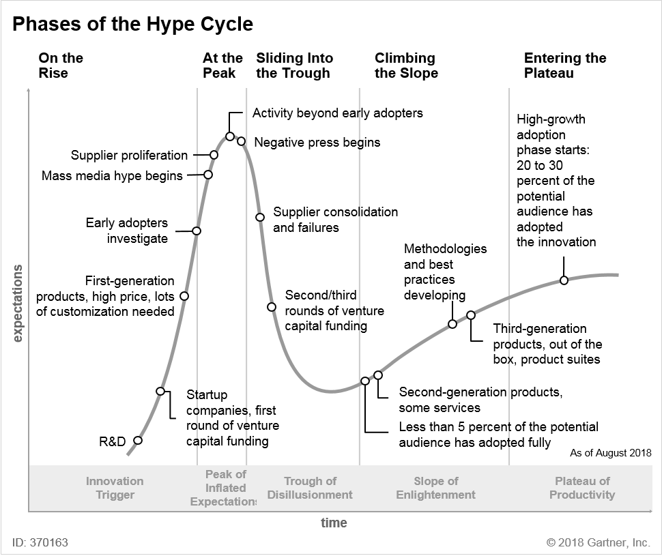

###### **On the Rise**

An Innovation Trigger is anything that sets off a period of rapid development and growing interest, and it will be different for each innovation. It may be a product launch, a major improvement in price/performance, adoption by a respected organization, or simply a rush of media interest that socializes and legitimizes the concept. It may also be a trigger external to the IT industry, such as new legislation or the demands of an economic or political crisis. Some innovation profiles can have an extremely long R&D preamble before they reach a meaningful trigger point, including several false starts with minor peaks and troughs. The Hype Cycle cannot start until a sufficient number of interested parties are actively discussing the innovation’s potential.

Many types of innovation that are not usually thought of as technologies can be charted on a Hype Cycle. These include innovations such as management techniques (for example, enterprise architecture, digital business and agile software development). For this reason, we now refer to the beginning of the Hype Cycle as the Innovation Trigger, rather than the Technology Trigger as we had previously.

The gap between trigger and peak is often quite short. For an innovation that takes 10 years from trigger to plateau, the rise from trigger to peak might take only one to two years. Consumer-driven innovation, such as social media, often experiences a particularly short prepeak period because the trigger for success is rapid, viral adoption.

The most common indicator that an innovation is past the trigger is that it is available for purchase from a commercial vendor rather than a lab. Other indicators that an innovation is past the trigger but has not yet reached the peak include:

* Only a few suppliers are selling the innovation (often only one or two).
* The suppliers are funded by seed rounds of venture capital.
* An established provider brings a radically innovative product to market (such as Apple’s iPad).
* The innovation requires significant customization to work in an operational environment. The customization is performed mainly by the supplier.
* The price is high relative to the cost of production and to the cost of related, but more established, products.
* Suppliers are not yet able to provide references or case studies.

###### **At the Peak**

At the Peak of Inflated Expectations, the innovation seems to be featured on the front cover of every business and industry magazine, or be the subject of every computing-related blog or tweet. Suppliers use the latest buzzwords in their marketing to make their offerings more attractive, and the marketplace is flooded with overlapping, competing and complementary offerings. When investors see an emerging hot spot in the market, they want “one of those” in their portfolio, which encourages the proliferation of companies with similar offerings.

As word of the innovation spreads, companies that like to be ahead of current thinking adopt it before their competitors. The suppliers of the innovation boast about their early prestigious customers, and other companies want to join in to avoid being left behind. A bandwagon effect kicks in, and the innovation is pushed to its limits as companies try it out in a range of settings. At this point, the innovation is viewed as a panacea, with little regard for its suitability for each application. Stories in the press capture the excitement about the innovation and reinforce the need to become a part of it or be left behind. The pressure on companies to adopt it, in many cases without a full understanding of the associated challenges and risks, is intense.

Hype in the consumer world may last from a few months to a year or more. In the commercial world, the peak of hype usually lasts at least a year because of the slower pace of corporate decision making and investment. Major peaks, such as the dot-com era or “green” technology, may last for two or three years.

Indicators that an innovation is at the peak include:

* The trade and business press run frequent stories about the innovation and how early adopters are using it.
* A popular name catches on in place of the original, more academic or specialist engineering terminology. For example, the wireless networking technology called “802.11g” became “Wi-Fi.”
* Analysts, bloggers and the press speculate about the future impact and transformational power of the innovation.
* Simple, exaggerated, nonspecific declarative marketing slogans appear, such as “I have cloud power” and “cloud is the answer.”
* A surge of suppliers (often 30 or more) offer variations on the innovation.
* Suppliers with products in related markets align their positioning and their marketing with the theme of the innovation.
* Suppliers can provide one or two references of early adopters.
* Investors aggressively seek a representative supplier for their portfolio. Some early stage venture capitalists may sell at this point.
* Established companies buy one or two early leading suppliers in expensive, high-profile acquisitions toward the end of the peak.

###### **Sliding Into the Trough**

The same few stories of early success have been repeated over and over, but now a deeper look often shows those same companies still struggling to derive meaningful value. Many of these failures center on inappropriate uses of the innovation. Less-favorable stories start to emerge as most companies realize things are not as easy as they first seemed. The media, always needing a new angle to keep readers interested, switches to featuring the challenges rather than the opportunities of the innovation. The innovation is rapidly discredited because it does not live up to the early, overinflated expectations of organizations and the media.

There is not always a drop in the overall adoption numbers as an innovation slides into the trough. Instead, the anticipated rapid growth in adoption may simply be delayed. What suppliers and investors expected to be a “hockey stick” uptake remains a slow-growth path. As a result, supplier consolidation and failure occur because there is too little adoption growth to sustain so many similar products.

The length of the trough is one of the most variable parts of the Hype Cycle. With the average length of the trough ranging from two to four years, a rapidly moving innovation may suffer a temporary setback of six to nine months. Consumer-class innovations often have a particularly brief trough, usually associated with the security and compliance issues of adopting them for business purposes. Some innovations with challenging engineering or business case issues remain in the trough for a decade (see the Fast Track and Long Fuse sections).

Amid the disillusionment, trials continue and vendors improve products based on early feedback. Some early adopters benefit from adopting the innovation. For some slow-moving innovations, workable and cost-effective solutions emerge and provide value in niche domains, even while the innovations remain in the Trough of Disillusionment.

Indicators that an innovation is, or will soon be, in the trough include:

* Press articles turn negative, featuring the challenges and failures of the innovation. Terms such as “failure” and “backlash” are used in headlines.
* General cynicism exists about the transformational potential of the innovation.
* Supplier consolidation starts, including buyouts by larger companies and investors.
* Suppliers need second- and third-round funding from investors.
* Suppliers use the same few case studies and references of successful adopters.

###### **Climbing the Slope**

Over time, an innovation matures as suppliers improve products on the basis of early feedback, and overcome obstacles to performance, integration, user adoption and business case justification. Methodologies for applying the innovation are successfully codified, and best practices for its use are socialized.

By the time the innovation climbs the Slope of Enlightenment, many of the big lessons have been learned, and the reputation of the innovation is rising again. What is learned is incorporated into second- and third-generation products, and methodologies and tools are created to ease the development process. For some innovations, there is a significant new capability or a performance improvement that changes the value proposition and makes the innovation more broadly useful. The marketing of these maturing products or the new capability often acts as a minitrigger to launch the innovation out of the trough. In other cases, the change or improvement is slow and subtle. It may catch organizations unaware unless they are actively tracking progress.

At the beginning of the Slope of Enlightenment, the penetration often is significantly less than 5% of the potential market segment. This will grow to 20% to 30% as the innovation enters the Plateau of Productivity. The journey up the slope may last from one to three years.

Indications that the innovation is moving up the slope include:

* Suppliers of the innovation offer second- or third-generation products that work with little or no consulting from the supplier.
* Suppliers of technology innovations offer product suites that incorporate the innovation into a broader range of tools.
* Consulting and industry organizations publish methodologies for adopting the innovation.
* Press articles focus on the maturing capabilities and market dynamics of the suppliers.
* New success stories and references start to proliferate.
* Reliable figures regarding costs, value and time to value become available.

###### **Entering the Plateau**

The Plateau of Productivity represents the beginning of mainstream adoption, when the real-world benefits of the innovation are predictable and broadly acknowledged. By the time innovations reach the plateau, they are increasingly delivered as out-of-the-box solutions. As an innovation matures, particularly if it is a major, high-profile innovation, an “ecosystem” of related products and services often evolves around it. This may trigger a fresh Hype Cycle of the components of the ecosystem.

As an innovation achieves full maturity and supports thousands of organizations and millions of users, the hype around it typically disappears. The hype is replaced by a solid body of knowledge about the best ways to apply and deploy the innovation.

Indicators that an innovation has reached the plateau include:

* Trade journals and websites start to focus on best-practice articles about how to deploy the innovation.
* Clear leaders emerge from the many suppliers that joined the market on the Slope of Enlightenment.
* Investment activities focus on acquisitions and initial public offerings.
* Many examples of successful deployments exist in multiple industries.
* The terminology connected with the innovation becomes part of everyday speech. Examples include Googling, texting and blogging.

##### **Why the Hype Cycle Matters: Traps and Opportunities**

The constant barrage of positive and negative hype often leads organizations to behave in ways that may not represent the best use of their resources. The peaks and troughs of the Hype Cycle exert pressure on organizations to adopt risky technologies or innovations without knowing their potential value. They also mask opportunities to embrace less visible innovations that may be highly relevant. This leads to the four traps of the Hype Cycle — adopting too early, giving up too soon, adopting too late or hanging on too long (see Figure 5):

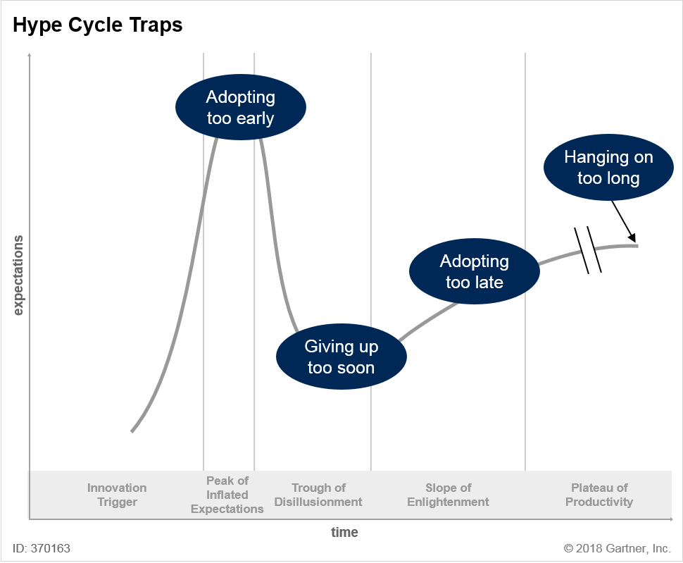

It is important to understand the traps that can snare unwary adopters. But it is equally important to examine the opportunities that arise from the inevitability of the Hype Cycle. Organizations that can predict major shifts in behavior — such as the major turning points on the Hype Cycle — can take advantage by being ahead of the crowd.

Two types of opportunity arise from the Hype Cycle:

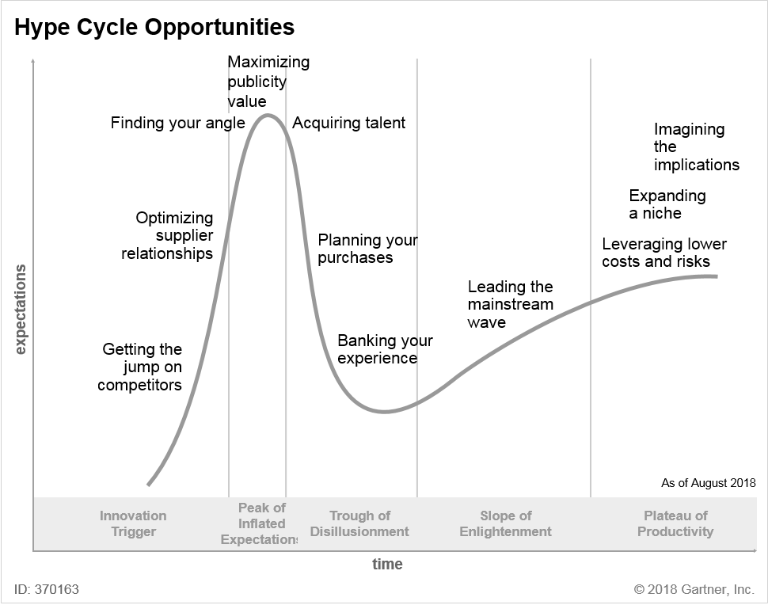

##### **How to Use the Hype Cycle: Adoption Strategies**

To make a good decision about when to adopt an innovation, organizations must balance three variables:

* How potentially valuable the innovation is to the organization
* Where the innovation is on the Hype Cycle
* How good the organization is at tolerating and managing risk

Organizations tend to be classified as one of three types with regard to innovation adoption:

* **Type A (aggressive):** In general, these organizations try to adopt innovations early in the Hype Cycle. They are prepared to accept the risks associated with early adoption in return for the rewards.
* **Type B (the majority):** These organizations try to adopt innovations in the middle of the Hype Cycle. By doing so, they learn from the experience of Type A organizations but do not wait so long that they lag behind their competitors and become Type C organizations.
* **Type C (conservative):** These organizations try to minimize risks by adopting innovations late in the Hype Cycle, once they have reached the Plateau of Productivity.

However, organizations that operate exclusively within their comfort zones miss opportunities. They always tend to adopt innovations early, or late, in line with their organization personalities (see Figure 7).

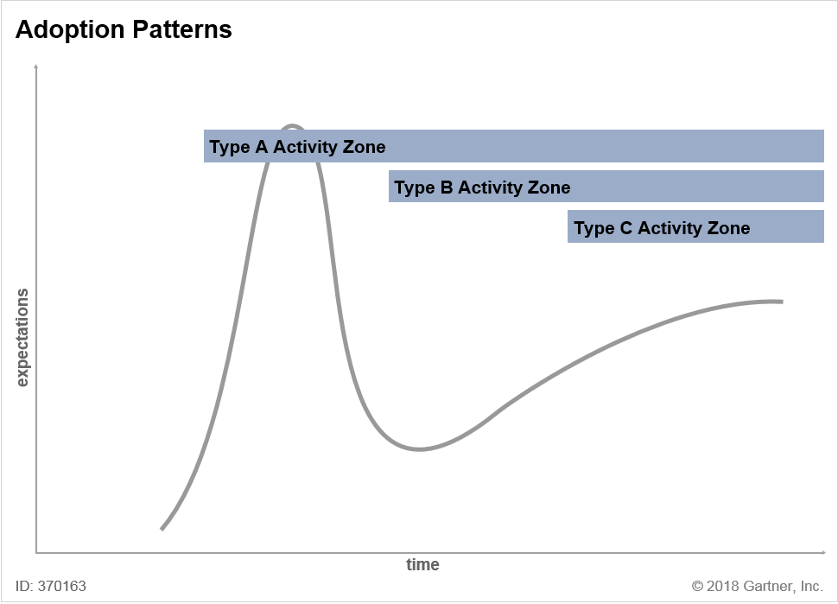

Organizations should recognize their risk comfort zones, but be prepared to step outside them depending on the strategic importance of an innovation. They should be *selectively aggressive*. Even Type A companies should be selectively aggressive regarding the innovations they adopt early, as not all innovations are worth the risk. Conversely, Type B and Type C enterprises should consider adopting innovations early if the innovations contribute to key business objectives. Type B companies face a particular challenge in avoiding the “adopting too early” trap, as they are lured out of their comfort zones by market hype and executive expectations (see Figure 8). Organizations should take special care at extreme highs and lows of economic cycles when fiscal pressures compound the hype effect. Examples include the rush to e-business opportunity risk taking in 2000 and overzealous high-risk offshoring in an attempt to lower costs in 2003.

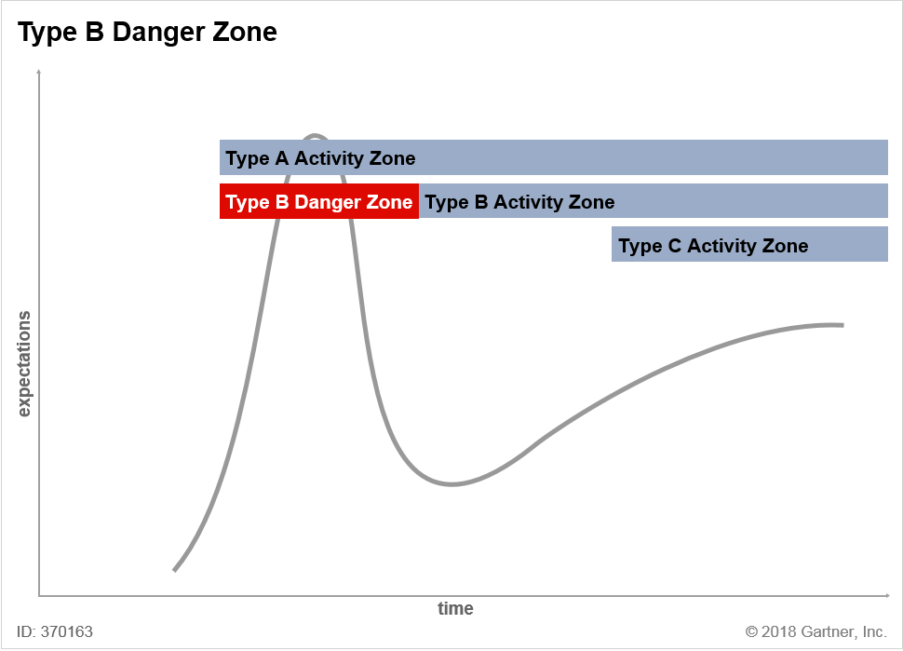

Some innovation leaders use Hype Cycles as a way to structure a discussion about their innovation candidates with their executives. One useful focusing mechanism is to divide the chart into two parts: pre- and post-trough (see Figure 9). For pre-trough innovation profiles, the team asks itself, “What’s here that we could be using?” It discusses where it is worthwhile to adopt aggressively, even if it is outside the organization’s usual comfort level. For innovation profiles positioned after the trough, the team asks, “What’s here that we are not using?” In other words, the team discusses what the organization is missing and whether the team needs to do something about it. The insight from these discussions can inform an organization’s ranking and prioritization decisions. For more best practices in the innovation adoption process, see

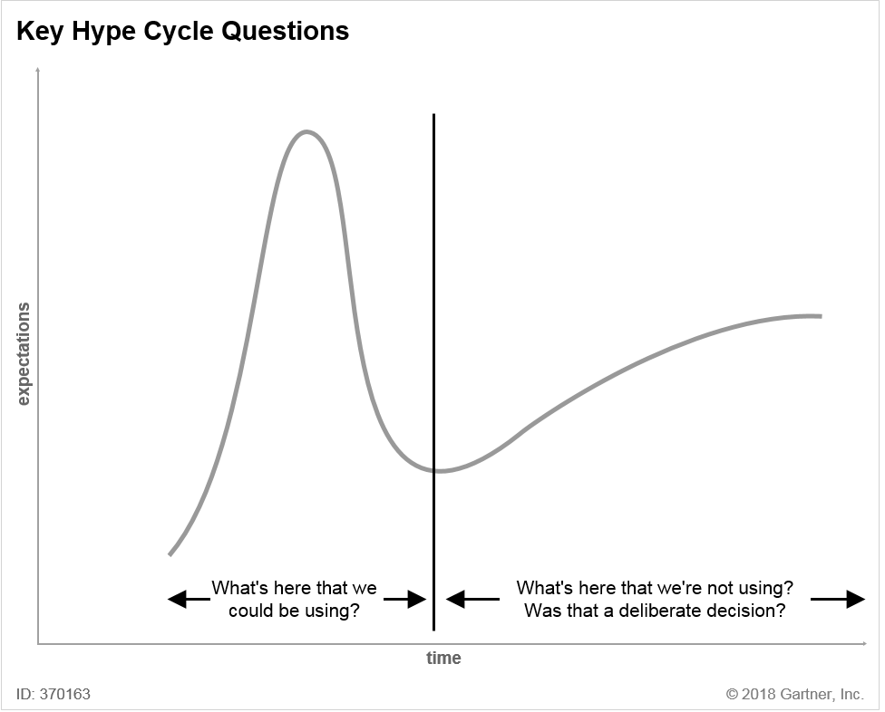

##### **The Hype Cycle Toolkit**

The Hype Cycle Toolkit (see ; we will publish an updated version in September 2018) is a planning tool based on Gartner’s annual Hype Cycle research. It pulls into a single spreadsheet more than 1,900 innovation profiles featured in the Hype Cycles published as part of the annual Special Report. Innovation planners can filter, search and sort the spreadsheet entries to generate a shortlist of innovation profiles for discussion in IT portfolio and strategic planning meetings. The Toolkit also has a feature that enables users to autopopulate a custom Hype Cycle with their selected innovation profiles.

Ways to take advantage of the Hype Cycle Toolkit include:

* Searching the spreadsheet for innovation profiles relevant to specific initiatives for business partners.
* Keeping the spreadsheet available as a resource for technology research and enterprise architecture planning (for example, looking up definitions or vendors).
* Creating a Hype Cycle of innovation profiles that the organization is adopting or evaluating. This will enable the organization to educate business or IT audiences about the peaks and troughs in expectations that they can expect as the innovation profiles mature.
* Using the spreadsheet to drive creativity at IT or management off-site meetings. For example, organizations can select early stage innovation profiles (with maturity levels of “embryonic” or “emerging,” or with a Hype Cycle position before the peak). They can then ask, “Could this innovation bring us a competitive advantage?”
* Using the spreadsheet as a risk-reduction tool. Organizations can check through later-stage innovation profiles to ensure they do not inadvertently miss out on a key innovation that is entering maturity. By doing so, they will avoid being left behind in their industry.

##### **The Priority Matrix**

Organizations use the Gartner Hype Cycle to provide a snapshot of the level of hype and rate of maturation of a set of innovation profiles. The Hype Cycle is an excellent educational tool for showing business and other executives the common pattern of excitement and subsequent disillusionment that accompanies innovations.

However, for internal planning and the prioritization of emerging innovation profiles, technology planners must look beyond the hype. They must assess innovation opportunities in terms of their relative impact on the organization. The Priority Matrix (see Figure 10) is a useful tool for presenting this information. Hype Cycle reports contain a Priority Matrix for the same set of innovation profiles featured on the Hype Cycle.

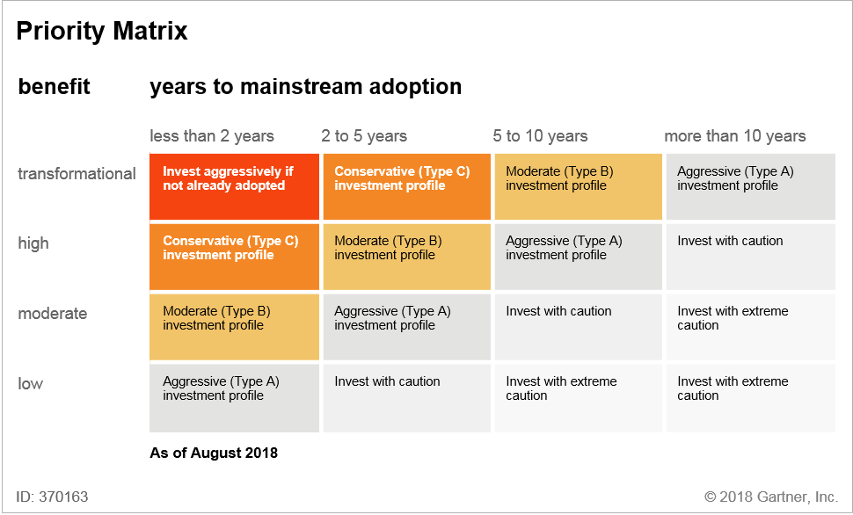

In the Priority Matrix, the vertical axis focuses on the potential benefit of the innovation (rather than on the hype/expectation levels presented in the Hype Cycle). Options for the benefit rating are:

* **Transformational:** Enables new ways of doing business within and across industries that will result in major shifts in industry dynamics
* **High:** Enables new ways of performing horizontal or vertical processes that will result in significantly increased revenue or cost savings for an organization
* **Moderate:** Provides incremental improvements to established processes that will result in increased revenue or cost savings for an organization
* **Low:** Slightly improves processes (for example, improved user experience), but will be difficult to translate into increased revenue or cost savings

The horizontal axis groups the innovation profiles according to the same years-to-plateau rating used on the Hype Cycle. The years-to-plateau rating is a simple measure of risk based on the projected rate of maturation for an innovation. Organizations can calculate a more complex risk rating by combining:

* The market penetration and maturity ratings
* The years-to-plateau rating and position on the Hype Cycle
* Project-specific factors, such as cost and level of organizational disruption

Innovation profiles rated as “Obsolete Before Plateau” do not appear on the Priority Matrix.

High-priority investments are in the top left of the Priority Matrix, where innovation profiles have a potentially high impact and have reached a reasonable level of maturity. Organizations that are conservative in their innovation adoption (Type C organizations) may limit their focus to this area. Organizations that are more aggressive technology adopters (Type A and Type B organizations) are probably already using innovations that will mature in less than two years. They will probably want to evaluate innovation profiles further to the right or lower on the Priority Matrix. For example, such organizations will be interested in assessing innovation profiles that will not be in widespread use for at least five years, but that may provide a competitive edge in the interim.

As with the Hype Cycle position and the years-to-plateau assessment, we provide a subjective, peer-reviewed opinion on the most appropriate benefit rating of each innovation. The benefit rating we assign reflects an average, cross-industry benefit. For industry-specific Hype Cycles, the benefit rating reflects the average benefit within that industry. The potential benefit for a specific organization may vary considerably from this average perspective. Technology planners should be prepared to replace the average benefit rating with their own customized version for innovation profiles in their portfolio.

There may also be some interorganization and interindustry variations on the horizontal years-to-plateau axis, but typically to a lesser degree than on the benefit axis.

The value of the Priority Matrix lies in concentrating the discussion on where an organization should focus its evaluation of emerging technologies. In particular, it is a useful framework for:

* Making explicit judgments about the potential benefits of an innovation in an organization.
* Defending against personality-driven investment decisions, whereby an influential individual champions an innovation or project that may not be the best investment for the organization. The Priority Matrix enables technology planners to show how the proposed innovation compares with other candidates in terms of benefit and risk.

##### **Other Hype Cycle Fields**

In addition to the data points used to create the Hype Cycle and Priority Matrix graphics, Gartner Hype Cycle reports contain descriptions of each innovation profile on the Hype Cycle. These descriptions include:

* A definition of the innovation
* A justification for the innovation’s positioning
* User advice
* The innovation’s business impact areas
* Benefit rating
* Sample vendors (examples, not a comprehensive listing)

These descriptions also include two other ratings: maturity and market penetration.

###### **Market Penetration**

The ranges for market penetration — the current penetration as a percentage of the anticipated target market — are:

* Less than 1% of target audience
* 1% to 5% of target audience
* 5% to 20% of target audience
* 20% to 50% of target audience
* More than 50% of target audience

For some innovation profiles, assessing the market penetration is relatively straightforward. For a mobile phone, for example, the percentage of the population that owns one would be a simple measure of progress. However, there are a number of complicated aspects in deciding a figure for market penetration, including:

* **Estimating the ultimate penetration level.** At the start of an innovation, the projected target market may be wildly misjudged. When mobile phones were first commercialized in 1984 at approximately $4,000, the target market might have been viewed as “all mobile business executives.” More ambitiously, some may have hypothesized that the maximum extent of the market would be that, one day, every person in a country might have a mobile phone. Some might also have predicted the amount of use based on substituting half, or even all, of the existing landline telephony minutes consumed per person at that time. Nobody would have forecast the volume of minutes consumed today, the time spent using devices for other things (such as game playing) or that the total number of active handsets would commonly exceed 100% of the population. For the purposes of Hype Cycle research, the expected target market is likely to be the saturation that analysts expect in 10 to 20 years.
* **Determining when an individual has adopted an innovation.** If a user has joined a social networking site but has visited only twice in the past year, should that user be viewed as having “adopted” social networking in determining the current penetration? In general, we regard an innovation as adopted only if it is used regularly.
* **Determining when an organization has adopted an innovation.** Organizational adoption is complicated by the distinction between an organization’s acquisition of an innovation and its use of it. An innovation may penetrate deeply in a small number of organizations or only slightly in a large number of organizations. So the percentage of organizations using an innovation does not necessarily equate to the number of actual current users (for example, as measured by seats or copies of software) as a percentage of all future users. When assessing the penetration level, we must consider the number of copies or seats of a technology deployed and used regularly within the organization. This issue is compounded by the proliferation of cloud and SaaS models.
* **Determining the appropriate measure of granularity for adoption.** For some innovation profiles, the “target user base” within the organization is not individual users. The target user base may be development teams (for example, reusing service-oriented architecture [SOA] across a large organization) or whole business units (for example, opting into a master data management [MDM] strategy). For these complex organizational innovations, progress is harder to measure because it involves the scope of adoption. Using SOA in a couple of small projects is not the same as full-scale adoption of SOA as an organizational standard. Deploying one function in a CRM suite is not the same as rolling out a customer-centric corporate strategy. When measuring the current penetration of complex technologies and innovations, we must consider the level of sophistication of current deployments compared with what is possible in the midterm to long term.

To stay true to standard industry definitions of market penetration, we use the following default measure for Hype Cycle market penetration:

We review market penetration levels for each innovation with each update to reflect changes in adoption and the addressable market. In cases where the addressable market grows significantly, we may reduce our figure for market penetration.

In some cases, the more relevant statistic is the raw percentage of organizations that have adopted an innovation or discipline, without regard for the level of internal penetration. In these cases, we use the percentage of adopting organizations instead of true market penetration. When we do this, we explain it in the Position and Adoption Speed Justification or Business Impact section of the innovation profile’s description.

###### **Correspondence Between Hype Cycle Fields**

Table 2 shows the expected correspondence between the various fields of an innovation profile. Exceptions to this typical pattern may exist. Examples include when an innovation is mature but has not achieved good penetration (niche technologies), or when an innovation is very slow moving, is climbing the slope but is still more than five years to the plateau. We explain such exceptions in the Position and Adoption Speed Justification section of the innovation profile’s description.

###### **Maturity Rating**

Table 1 shows the options for the maturity rating, although mature mainstream, legacy and obsolete innovation profiles are not typically included on Hype Cycles.

##### **Hype Cycle Q&A**

Here we answer some frequently asked questions about Hype Cycles.

**Q. Does the Hype Cycle apply to IT only or does it work for areas such as surgical treatment, politics, biofuels and management techniques?**

**A.** We devised the Hype Cycle by observing innovations, but it works for many situations where the following conditions exist:

* An innovation is clearly identifiable and has a defined scope — whether it’s a new management technique, medical treatment, etc.
* There is an ecosystem of stakeholders involved, such as those developing the innovation, those funding it and those applying it in their organizations.
* The innovation evolves as stakeholders learn more about it and apply it in practice.

People outside of Gartner have applied the Hype Cycle to many non-IT topics, such as nanotechnology, medicine and food products. Gartner has created Hype Cycles in non-technology-centric areas, such as sustainability and business trends (see ). However, the Hype Cycle does not apply to pure fashion or fads. These tend to trend up and down with nothing — no artifact, core idea, talent or other value — to pull them out of the trough and on to eventual productivity.

**Q. Why is it called the Hype Cycle, when it’s not a true cycle, just a curve?**

**A.** The actual shape of each Hype Cycle is a dampened wave, not a cycle — it does not have a loop backward like a true cycle would. This is because it is not the innovation profiles themselves that loop around. They progress inexorably toward maturity (or obsolescence), albeit at a slower pace than we want or expect. The cycle relates to the behavior of *people*. As individuals, as members of organizations, as marketplaces and as industries, we follow a cycle of enthusiasm and disillusionment with each innovation or trend.

**Q. Is the Hype Cycle based on empirical science?**

**A.** The Hype Cycle is a structured, qualitative analytical tool. There is no single measure for expectations (the vertical-axis variable), but we find evidence, such as surveys and forecasts, useful in helping establish positions. The Hype Cycle is not a mechanically derived quantitative chart. Its strength lies in combining evidence data and expert human judgment. The Hype Cycle is a working management decision tool, not an academic endeavor. But we welcome third-party research that further evolves the model and guidance on related adoption decisions.

**Q. Is the Hype Cycle the same as Geoffrey Moore’s “Crossing the Chasm”?**

**A.** The Trough of Disillusionment coincides with the “chasm” in Geoffrey Moore’s classic book on technology marketing, “Crossing the Chasm: Marketing and Selling Disruptive Products to Mainstream Customers.” During this stage, vendors need to increase product adoption from a few early adopters to a majority of organizations to begin the climb up the Slope of Enlightenment. The chasm model does not have the equivalent of the Peak of Inflated Expectations. The vertical axis of the chasm represents adoption levels, as described in Everett Rogers’ “Diffusion of Innovations,” rather than expectations. We view Moore’s chasm work and the Hype Cycle as analytic yin and yang. The chasm is written from the innovation originator (vendor) perspective, while the Hype Cycle takes the innovation adopter (buyer) point of view. The main management issues and key decisions faced by each side are different.

**Q. Does everything take the same time to pass through the Hype Cycle?**

**A.** No. People often misunderstand this by skim reading, or seeing the Hype Cycle republished on the web without its supporting key. We show each item taking a different time to plateau. There is no fixed timeline on the Hype Cycle. Fixing the timeline on the horizontal axis would make it impossible to compare disparate innovation profiles because they move at different rates.

**Q. Do things go around the Hype Cycle several times?**

**A.** In most cases, no. Rarely, over a very long period, there may be more than one Hype Cycle iteration as an innovation seems to cycle between the peak and the trough. We refer to these as “phoenix innovations.” Agents are a prime example of a phoenix innovation. Agent technology is embedded in certain product classes that have matured (for example, network management and comparison shopping), but there are many other capabilities and interpretations of agent functionality that re-emerge year after year. In this case, the individual applications move through the Hype Cycle, while the higher-level concept seems to cycle.

**Q. Do things fall off the Hype Cycle?**

**A.** Very little “falls off” the Hype Cycle if innovations are tracked based on capabilities, rather than specific ways of delivering the capabilities. Failure typically occurs where there are multiple ways to deliver the same capability or benefit. For example, broadband connectivity has made its way through the Hype Cycle over the past decade, but some of the techniques to deliver it (such as ISDN and broadband over power lines) have fallen off the Hype Cycle. Other techniques (cable modem and DSL) have reached maturity. The actual capabilities — broadband, speech recognition, biometrics and videoconferencing, for example — do not fall off the cycle. But specific techniques, protocols, operating systems, products and devices may be supplanted by alternatives. Obsolescence before the plateau is most common in the area of telecommunications and standards. But true obsolescence (rather than just renaming or becoming embedded in a broader technology) is rare on the Hype Cycle.

When we remove an innovation profile from a Hype Cycle, we explain why in the Off the Hype Cycle section of the Hype Cycle report.

**Q. Do organizations and products follow the Hype Cycle?**

**A.** Occasionally, and under very specific conditions, the fortunes of an organization can follow the Hype Cycle. As an example, for Amazon’s first eight years, its stock price followed a perfect Hype Cycle curve. For this to happen, the organization must be associated with only a single innovation. However, it is not usually helpful to use the Hype Cycle in this way. We typically use the Hype Cycle to track innovation profiles at the “class of products” level, rather than at the level of individual products and organizations. So “cloud computing” appears on a Gartner Hype Cycle rather than “Amazon S3.”

Sometimes a single vendor becomes so synonymous with a new capability that devising a generic description feels unnatural. Most people identify with “YouTube” more than “consumer-generated media” and “Twitter” remains more recognizable than “microblogging,” even as the capability becomes embedded in other social networking tools. But, in general, the capability level, rather than a specific organization, product or service, is a more useful way to track and evaluate an innovation.

**Q. Can an innovation be at different points on the Hype Cycle in different industries or regions?**

**A.** Yes. Gartner creates industry-specific and region-specific Hype Cycles to show that some innovation profiles are more important, and may be at different positions in different industries or regions. In some industries and regions, technologies may be further behind or ahead than the general position, but in most cases the variation is more specific than that. For example, even though technology adoption may be lagging in many emerging economies, mobile peer-to-peer payments are much further ahead than in developed nations because of the lack of alternative infrastructure for centralized banking.

**Q. How do the Hype Cycle and Priority Matrix relate to Magic Quadrants and IT Market Clocks?**

**A.** The Hype Cycle and Priority Matrix are two of several graphical tools that Gartner uses to assess technologies and innovations:

* **IT Market Clocks:** Hype Cycles track the expectations of innovations from their emergence through early maturity. IT Market Clocks highlight the market progress of IT assets from the first time they can be used to when they must be retired. Both models depict “relative time,” and the two overlap, although the coverage of IT Market Clocks is longer. IT Market Clocks are complementary to Hype Cycles and fulfill a separate objective. In simple terms, Hype Cycles support “technology hunting” decisions about innovation adoption, while IT Market Clocks support “farming” decisions for assets already in use. Many innovations that move off Hype Cycles when mature continue to be represented as assets on IT Market Clocks as they progress through their useful market lives.

**Q. Has the Hype Cycle accelerated since you introduced it?**

**A.** We are asked quite frequently whether the Hype Cycle has “sped up” since we introduced it in 1995. At the heart of this question is a feeling that the pace of innovation has accelerated and that innovations are appearing at an ever-increasing rate.

One type of innovation does seem to move at a much higher speed through the Hype Cycle. These are the innovations that arise from the consumer web world, in particular those that involve collaboration and social networking. These technologies, as typified by YouTube, Facebook and Twitter, seem to launch fully formed and move rapidly from the Innovation Trigger to the Peak of Inflated Expectations, often in less than a year. There is still some disillusionment as individuals decide how to manage a new source of potential information overload, and organizations wonder how to find the business value. For corporate adoption in particular, it may still take several years for the innovation to move from the peak to the Plateau of Productivity. But overall, the path is distinctly more rapid than that of an innovation on a traditional, multidecade Hype Cycle.

The feature that distinguishes these innovations is that they emerge not from years of visible, documented laboratory R&D, but from the viral melting pot of the web. For every Facebook and Twitter, a thousand similar ideas were mooted that did not have quite the right set of features, or the right interface, to rise above the crowd. Once the next viral site emerges, it has already won a Darwinian battle and is ready for broader adoption.

Outside of this class of innovation, in most cases the overall speed through the Hype Cycle has not increased. Some of the innovations that are currently at the peak — such as 3D printing — have already been in the labs for decades. In particular, innovations that involve fundamental hardware advances, such as a new type of display or networking capability, tend to have a long period of laboratory fermentation. Overall, the pace varies considerably. Podcasting took only three or four years to travel through the Hype Cycle, but mobile commerce has taken 15 years so far and probably has another five or more years to go.

It is likely that a growing proportion of innovations will arise in the consumer world, particularly with the growth of platforms and app stores that encourage and reward a broad set of innovators. It will be important to track these sources, as well as traditional labs and vendors. But the Hype Cycle seems to be holding up as a pattern that reflects our attitudes to most types of innovation. Perhaps what is accelerating is not so much the pace of innovation itself, but rather society’s splintering levels of attention. These are causing us to cycle more rapidly between our peaks of enthusiasm for each new thing.

##### **Advanced Hype Cycle Topics**

###### **Hype Cycle Speed**

It usually takes years for an innovation profile to travel through the Hype Cycle — some may take decades. Normal innovation profiles with relatively few inhibitors usually travel through the Hype Cycle in five to eight years. Those that move faster are referred to as “fast track”; those that progress particularly slowly are called “long fuse.”

###### **Fast Track**

Fast-track innovation profiles go through the Hype Cycle within two to four years. This occurs when the maturity curve inflects early in the life cycle of an innovation (see Figure 11).

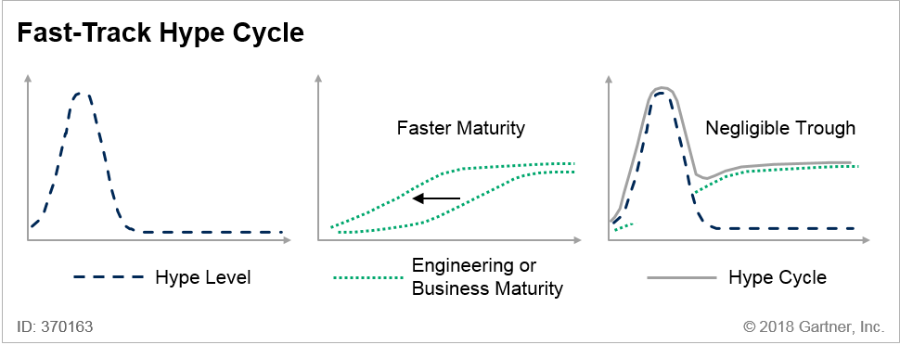

Many fast-track innovation profiles arise from the consumer web world. The move from consumer technology to the more demanding constraints of the organization (with respect to security, compliance, retention and more) is usually the cause of the trough in these cases.

Fast-track innovation indicators include:

* High value
* Simplicity of use by organizations and users
* Visibility of others using the innovation, which encourages viral adoption
* Several strong vendors that support the innovation
* Use of the current infrastructure
* Rapid transition from consumer to corporate use

###### **Long Fuse**

Long-fuse innovation profiles spend a longer-than-average time in the Trough of Disillusionment, resulting in a slower overall journey through the Hype Cycle — sometimes as long as one or two decades (see Figure 12). For example, PDAs were in the Trough of Disillusionment for several years after the launch of Apple Newton, until the PalmPilot was launched and firmly established a viable new class of device. Another example is object orientation, which took 10 to 15 years to migrate from academia and other research organizations to become a mainstream development technique. Object orientation took so long to cross the Hype Cycle partly because of skills and development process barriers.

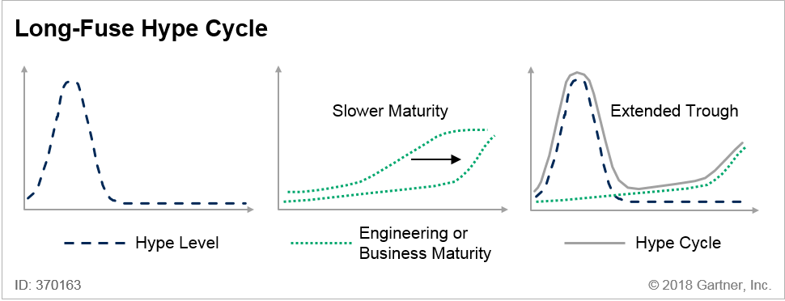

Long-fuse innovation indicators include:

* Inherent complexity that requires advances in basic science and engineering (for example, quantum computing and head-up displays).
* User acceptance or regulatory issues (for example, biometrics).
* Reliance on a new infrastructure or ecosystem that needs time to evolve (for example, online marketplaces with micropayments that facilitated the legal purchase of digital music).
* Dependence on professional skills that are unavailable or in short supply (for example, analytics, simulation or complex design).
* Major changes to business processes or the creation of a new business model (for example, CRM).
* A science-fiction-style fascination with the innovation that is far ahead of its real capabilities (for example, artificial intelligence, nanocomputing and robotics).

###### **Industry Variations**

The shape of the Hype Cycle can vary significantly across industries. As the number of uses for the innovation expands across different industries, the uses follow different paths up the Slope of Enlightenment and reach different Plateau of Productivity heights. Figure 13 shows this effect as a “horse tail” of plateau heights. It shows a simplified view of the evolution of RFID and its applications during the past decade. For a while, during the mid-1990s, the earliest proponents of the technology, such as Texas Instruments, were exploring many possible uses. As the market for RFID became more serious during the early 2000s, it focused on applications that would optimize the consumer packaged goods (CPG) supply chain to retail (following the so-called “Walmart mandate”). Other uses, such as airline baggage tracing, failed to show value in early pilots. As a result, RFID has settled at a lower level of adoption in the aviation industry than in retail.

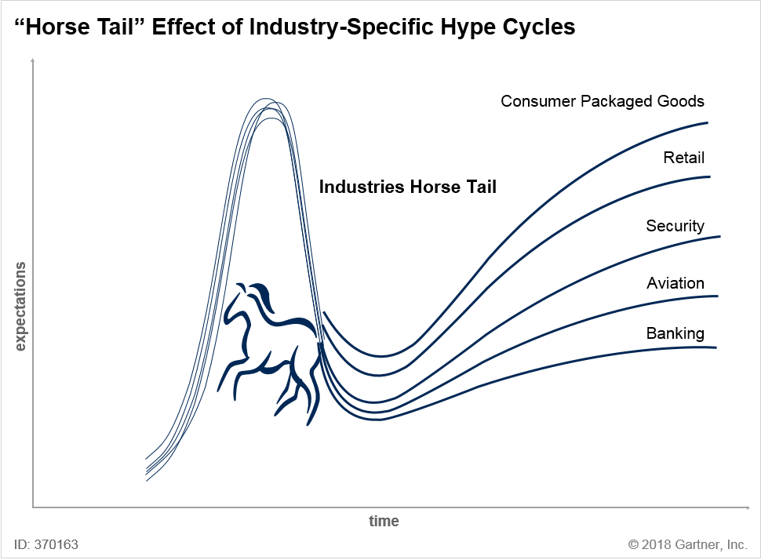

###### **“Double Peak” Hype Cycles**

In many technology markets, a second “minipeak” of hype may occur, triggered by product vendors. This launches the innovation up the Slope of Enlightenment (see Figure 14). As with the first peak, this minipeak often plays a beneficial role in alerting people that something has changed in the maturity or value proposition of the innovation.

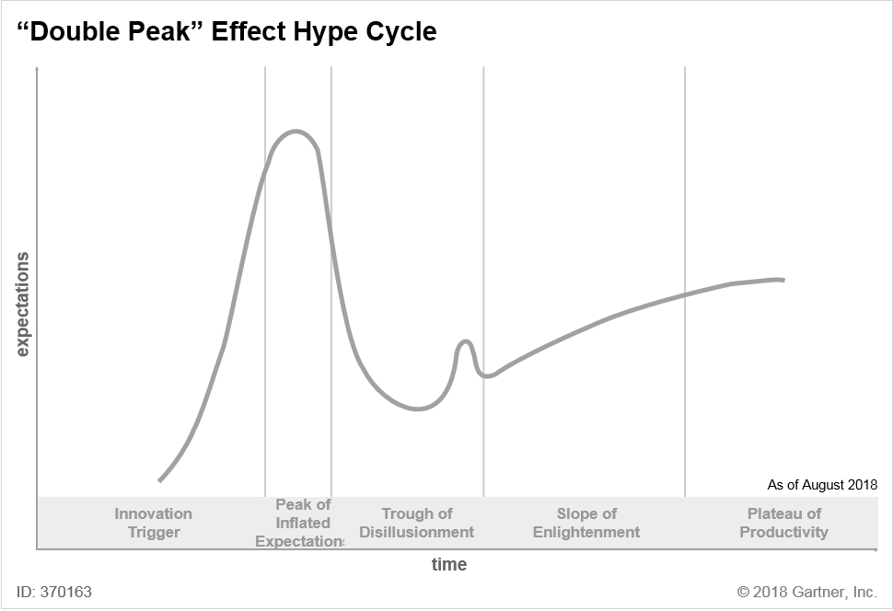

###### **Special Hype Cycle Circumstances**

Innovation profiles can experience special or unusual circumstances as they move through the Hype Cycle:

* Innovation profiles can become embedded. They cease to exist as a technology category or concept. Instead, the functionality is embedded in other products. For example, neural networks are now delivered as one of multiple techniques in analytic tools, rather than as the stand-alone products of the early 1990s.
* Innovation profiles can be split into several subconcepts (for example, cloud computing splits into public cloud and private cloud), as users differentiate between different application contexts and contextual requirements. Similarly, innovation profiles from different disciplines can merge and then re-emerge. For example, in the 1990s, machine learning from artificial intelligence and regression models from statistics merged to form data mining.
* Phoenix innovations continually cycle through enthusiasm and disillusionment (for example, intelligent agents and biometrics). Major events such as terrorist attacks or disease outbreaks can focus new attention on an innovation before it is even close to deserving peak status. Even prominent media articles can make some innovation profiles cycle through repeatedly. These innovation profiles are usually extremely slow-moving and have scientific or methodological challenges.
* “Zombie” innovation profiles (for example, internet terminals, interactive TV and video on demand) are placed on hold because they have failed to deliver on their promises. These innovation profiles work, but do not have enough user interest or business justification to drive adoption. They are usually in the Trough of Disillusionment for a long time before they become obsolete or re-emerge, often as embedded functionality in other innovation profiles.
* Innovation profiles can become obsolete or “extinct” before reaching the Plateau of Productivity. This premature obsolescence typically results from the emergence of a competing technology — for example, analog high-definition TV gave way to digital high-definition TV.

As part of the normal evolution of technology, the target audience for the innovation may change from that originally intended. The innovation’s applicability may grow to encompass new classes of users or shrink to become successful only in niche applications. Innovation profiles that have been reduced to niche applications include the artificial intelligence innovation profiles that were hyped during the 1980s, such as expert systems, virtual reality, genetic algorithms and fuzzy logic. Their original hype indicated that they should have had more impact. However, these innovation profiles may re-emerge from their current niche applications as part of a renewed focus on smart machines and cognitive technologies.

#### **Gartner Recommended Reading**

*Some documents may not be available as part of your current Gartner subscription.*

G. Moore. “Crossing the Chasm: Marketing and Selling Disruptive Products to Mainstream Customers.” Collins Business Essentials. 2014.

E. Rogers. “Diffusion of Innovations.” Free Press. 2003.

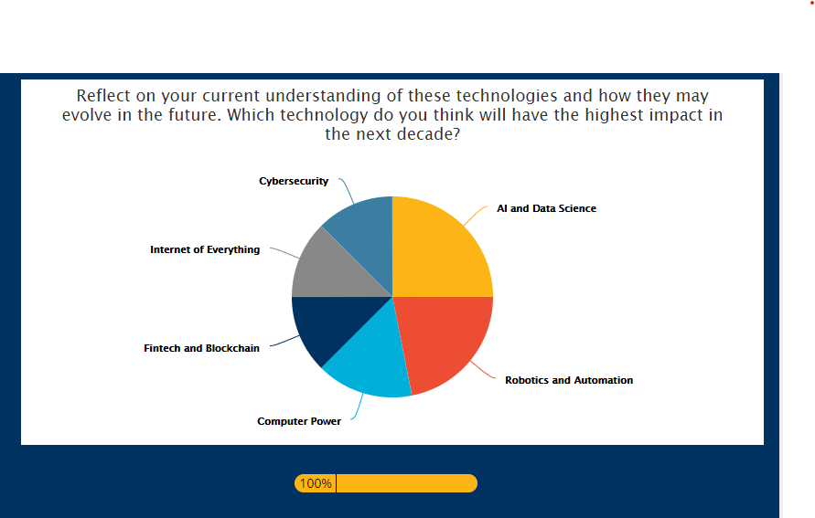





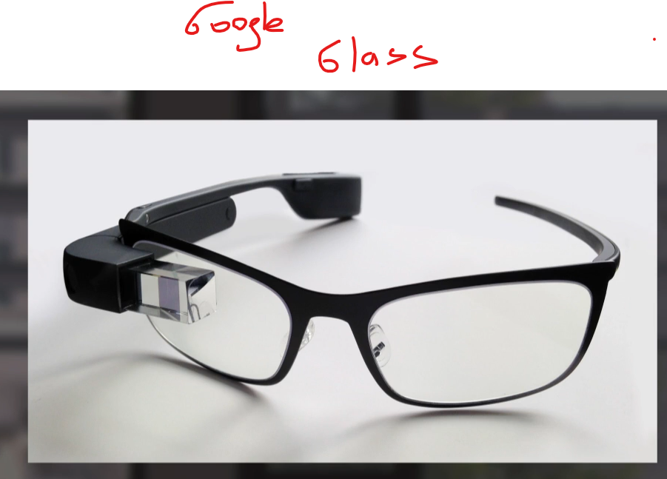

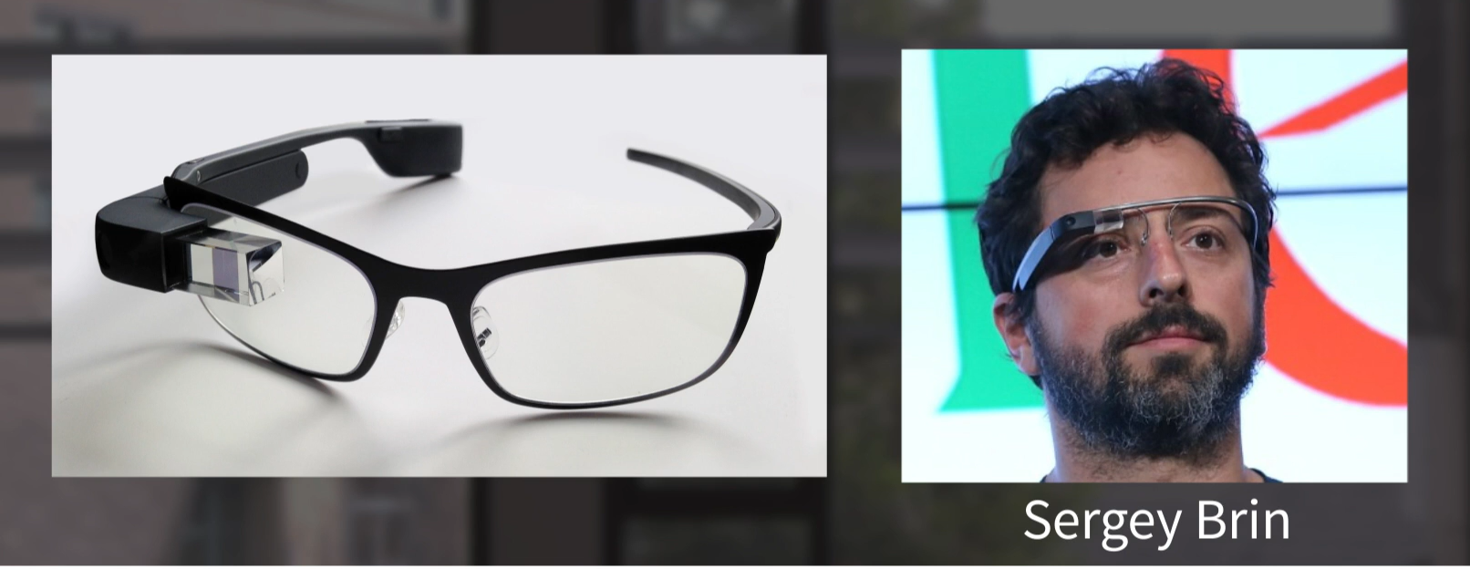



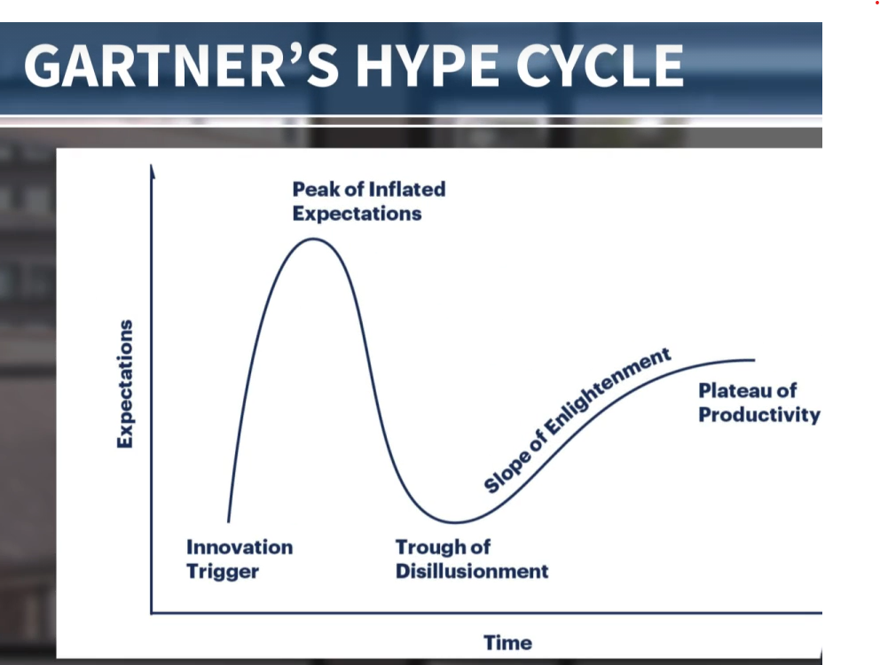

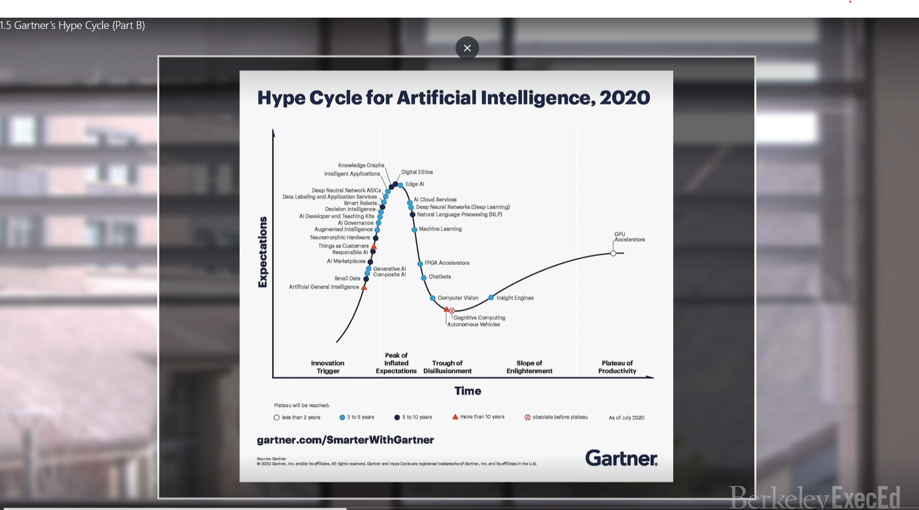

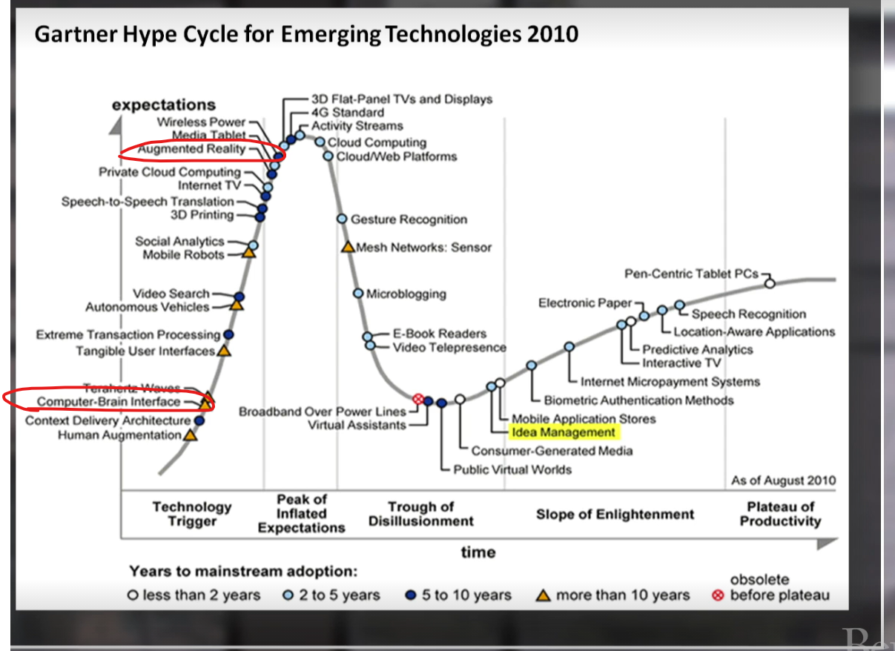

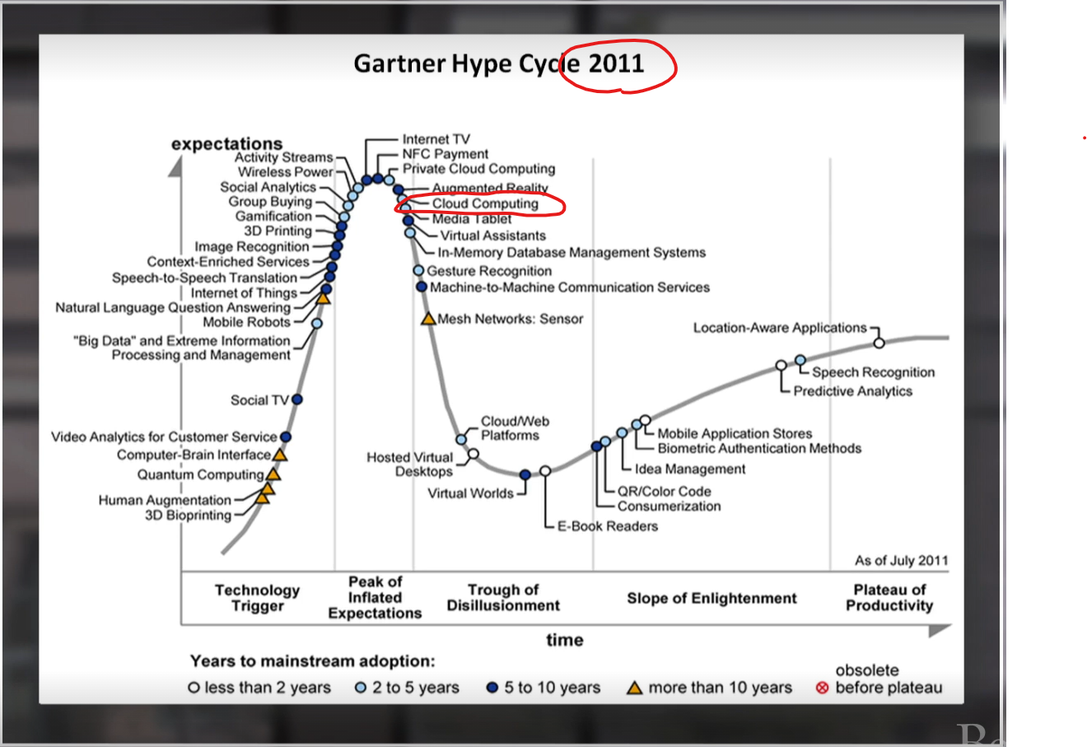

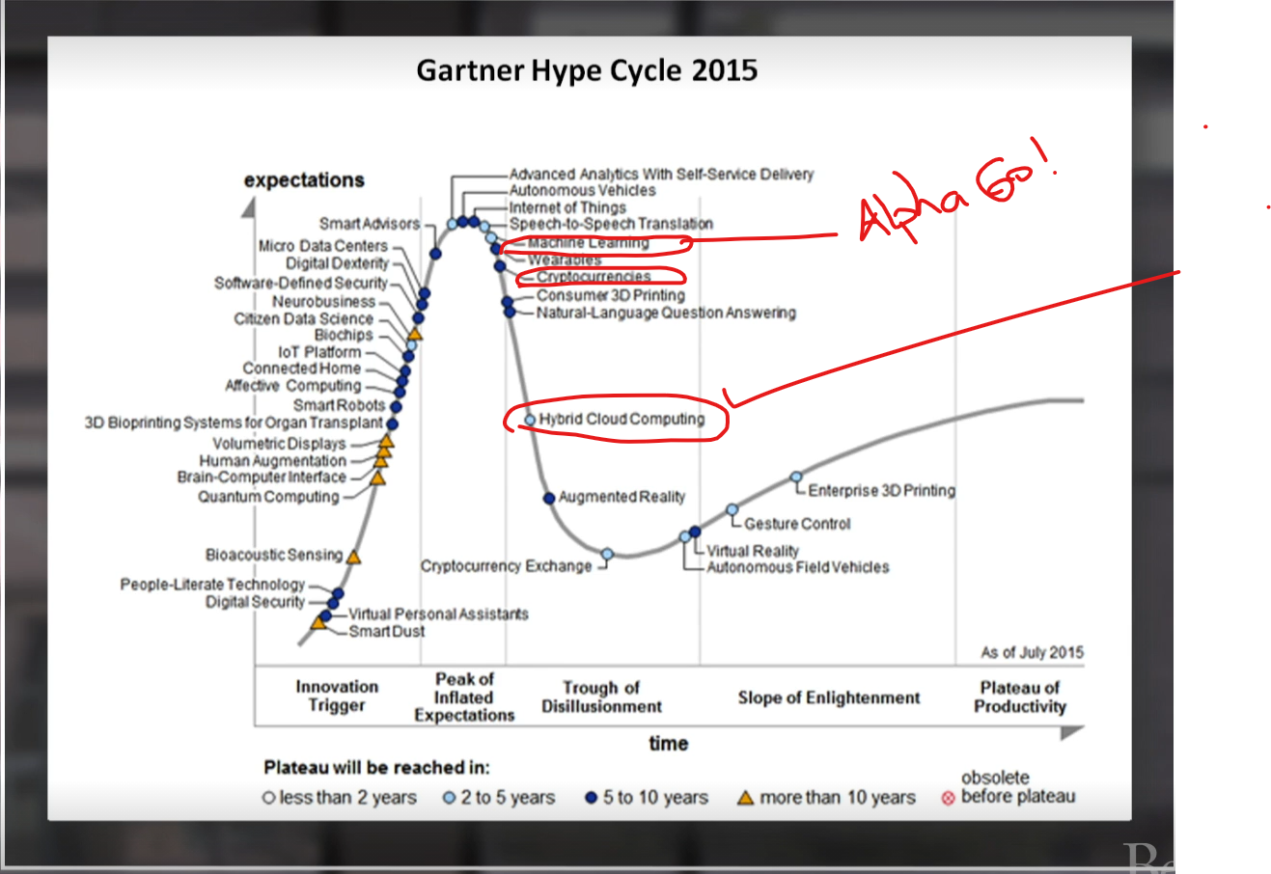

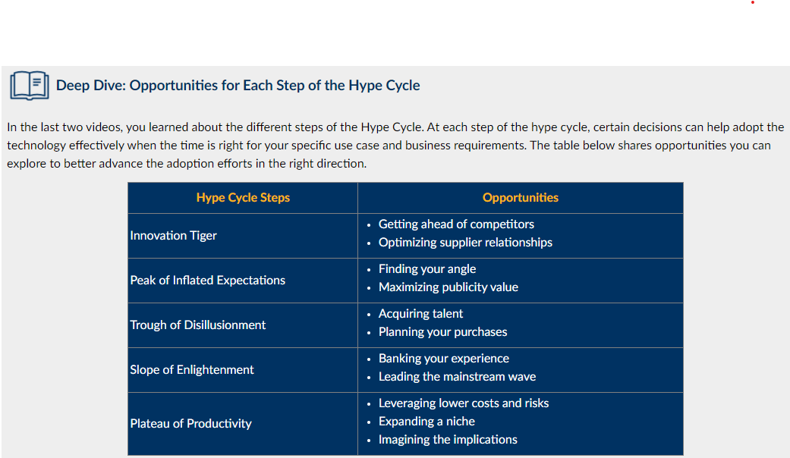

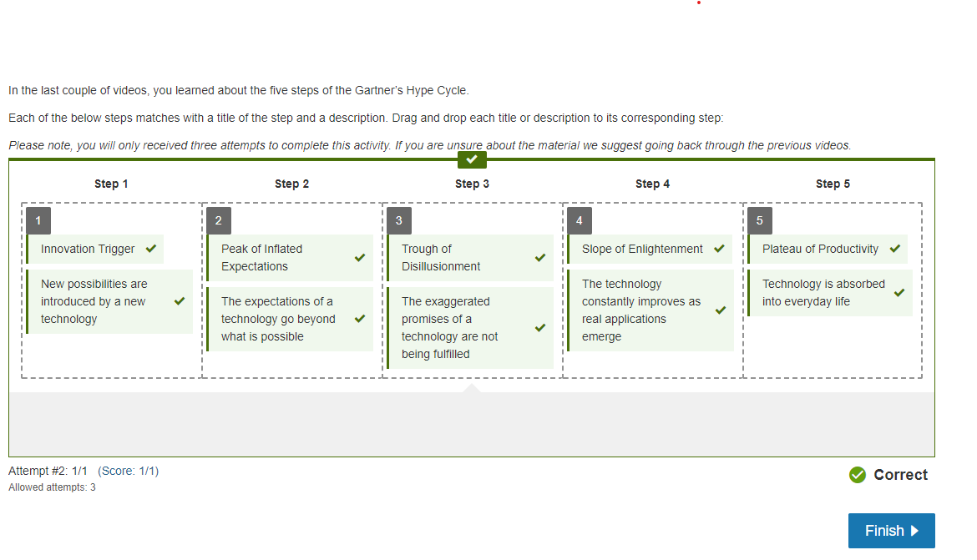

**Applying Gartner’s Hype Cycle to Leverage a Technology in Your Organization**

In Video 5, Professor Olaf Groth discussed how Gartner’s Hype Cycle has evolved over the recent years.

Now take a look at the [5 Trends Drive the Gartner Hype Cycle for Emerging Technologies, 2020 (Links to an external site.)](https://www.gartner.com/smarterwithgartner/5-trends-drive-the-gartner-hype-cycle-for-emerging-technologies-2020). Pick a technology in the cycle, and do some research about this technology online. Craft a discussion post that addresses the following:

* What technology did you select, and how would you describe this technology to those who are unfamiliar with it?
* Which step of the Hype Cycle is it currently in, and what does it mean?
* In what ways can your organization, or an organization of your choice, leverage this technology to achieve its strategic goals?
* Based on where the technology is in the Hype Cycle, what strategies could your organization deploy in the short- and long-term to better capture new opportunities enabled by this technology?

We encourage you to go through your peers' posts and share your feedback.

## [Adam Salmen](https://student.emeritus.org/courses/3412/users/144005)

ThursdayLocal: Sep 9 at 7:48pm<br>Course: Sep 9 at 11:48pm

[Manage Discussion Entry](https://student.emeritus.org/courses/3412/discussion_topics/188601?module_item_id=742255)

My company provides high performance materials for existing and new technologies. I specifically look at the electronics industry, and find hardware in need of our material properties. We use the Gartner hypecycle to plot new applications we could address with our materials, and revisit each application on a yearly basis to evaluate how much attention we should give to each application. One technology we are starting to focus more on now is AR/VR, because it has made it past the "trough of dissillusionment"  as a potential growth engine.

AR or Augmented Reality is the ability to have a digital canvas painted over reality- or human vision. This can either be through your phone, where the software plots objects over what the camera sees, or through glasses which can plot objects in your field of vision as you look through glasses.

VR, or Virtual Reality, is a totally emersive technology which puts the user in a virtual world, and allows them to interact with virtual objects through a screen, and usually have some type of tactile navigation system that they hold to navigate the virtual world.

AR/VR technology was identified as a relevant hardware technology which may have needs requiring our materials, but the production volume did not justify the investment in new materials for this special use.  I tracked have tracked this technology for several years at CES and in meetings with the top players (Microsoft,Google, Facebook, HTC ) and their vendors  (Kopin, Goertek, Foxconn) with little triggering of internal resources while it climed to the top of the hype cycle, and down into the trough of dispair.

As we see more use cases coming about (enterprise use for cheaper and contactless technical support for example, or the newly launched facebook/rayban glasses ) we start to approach the leading companies in this area, and ask if they need custom developments.

This allows us to not waste resources early on in the cycle, and only monitor. and only as real applications come about do we actually start engaging our operations, technology teams, and broader sales force to address the market.

plotting these technologies on a yearly basis helps us not waste resources too early, and also get comfortable with the landscape of developing technologies we could/should be working on as we evolve our business...

## [Rene Felder](https://student.emeritus.org/courses/3412/users/138032)

YesterdayLocal: Sep 10 at 3:27pm<br>Course: Sep 10 at 7:27pm

[Manage Discussion Entry](https://student.emeritus.org/courses/3412/discussion_topics/188601?module_item_id=742255)

I have chosen "Embedded AI data fabric", this means as IBM mentioned: "A data fabric supports better use of data as an enterprise asset by providing access to the right data just in time, regardless of where the data is stored. It is agnostic to deployment platform, data process, data use, architectural approach and geography while integrating core capabilities." [1] A data fabric helps to find data faster and better on time when it is needed. Today all companies and organizations have too much data but when they need them they cannot found the right data, so an AI driven data fabric helps to have the right data to the right time on access.

I am working in the financial industry and there it is important to have the right data available for example for fraud detection.

Source:  
[1] https://www.ibm.com/analytics/data-fabric

## [Jasmine Campos](https://student.emeritus.org/courses/3412/users/82697)

11:51amLocal: Sep 11 at 11:51am<br>Course: Sep 11 at 3:51pm

[Manage Discussion Entry](https://student.emeritus.org/courses/3412/discussion_topics/188601?module_item_id=742255)

I agree that Embedded AI Data Fabric will be an important technology that organizations should leverage to achieve critical business objectives. As more and more data becomes available, there is a need to have a more robust data management design and integration system across the Enterprise. Everything starts with having the right data!

## [Dana DeMeo](https://student.emeritus.org/courses/3412/users/163239)

YesterdayLocal: Sep 10 at 6:54pm<br>Course: Sep 10 at 10:54pm

[Manage Discussion Entry](https://student.emeritus.org/courses/3412/discussion_topics/188601?module_item_id=742255)

While reviewing the 2020 graph, **"2-way Brain Machine Interface (BMI)"** immediately caught my attention.

This is a technology to more efficiently, quickly and reliably facilitate brain-to-machine communication.  Our brains have extraordinary transmission speed estimated at 60,000 Terabits per second1, and are estimated to processes 1 exaFLOP (billion billion floating point operations) per second2.  While current machines cannot not yet scale to these levels, they are superior today in certain functions such as memory and calculations.  Additionally, as we will hopefully learn in this course, machines are gaining intelligence rapidly and are becoming superior in newer functions, such as judgement and decision making.

Therefore when contemplate a brain-computer system, we realize that the biggest challenge today is a **bandwidth problem**, not a processing problem.  Our traditional interfaces between the brain and a computer are simply too slow to benefit from the processing power on both sides.  Fingers on keyboards, eyes on screens, ears listening to speakers, voice speaking to microphones, etc. pale in comparison to what's possible with a direct link between the brain and a machine.  That is the technological goal of 2-way BMI - **speed up the pipe.**

The technology is currently in the Innovation Trigger Hype Cycle, indicating the nascence of the technology.  It's about 25% up on the curve with a 5-10 year plateau estimate.  Personally this "feels" too fast for me, but this probably exemplifies my lack of appreciation for how fast the technology is advancing.

Advanced companies such as Tesla, Google and Amazon will certainly benefit from this technology, as they can harness the faster "pipe" to add more and more value to the customer.  In fact, during my research I found a video with Elon Musk discussing a BMI project happening within Tesla right now.

Short-term strategies I would deploy include heavy investments into BMI technology to secure coveted patents and operational prototypes.  This is critical to gain Voice of Customer feedback using non-commercial prototypes.  This helps to define the requirements and investments needed for the products and solutions that eventually commercialize.  Long term strategies should involve investments in existing infrastructure and user experiences, in order to be ready to "plug in" BMI technology when it's ready.  I.e. proactively design products and services that are only applicable with a mature BMI technology, so that the company is ready to commercialize as soon as possible.

Sources:

(1) [https://blog.malwarebytes.com/artificial-intelligence/2019/08/how-brain-machine-interface-bmi-technology-could-create-internet-of-thoughts/Links to an external site.](https://blog.malwarebytes.com/artificial-intelligence/2019/08/how-brain-machine-interface-bmi-technology-could-create-internet-of-thoughts/)

(2) https://www.scienceabc.com/humans/the-human-brain-vs-supercomputers-which-one-wins.html

## [Jasmine Campos](https://student.emeritus.org/courses/3412/users/82697)

11:43amLocal: Sep 11 at 11:43am<br>Course: Sep 11 at 3:43pm

[Manage Discussion Entry](https://student.emeritus.org/courses/3412/discussion_topics/188601?module_item_id=742255)

The technology I selected is “Multiexperience (MX)”. Gartner describes this as “the new omnichannel for a digital-first world. MX is about the shift both in user experience perception and in interaction models, which leads to a multisensory, multidevice, multilocation and multi-touchpoint digital journey.”

Multiexperience is in the Innovation Trigger step in Gartner’s Hype Cycle.

The COVID 19 pandemic has accelerated the adoption of digital platforms. Users are becoming more comfortable with interacting using a variety of digital tools such as mobile apps, web, video sharing apps, and collaboration software and this trend will continue to rise. Organizations must address this shift by offering solutions/services that meet evolving user expectations to provide a seamless experience across a variety of digital touchpoints.

Organizations must start to evaluate growth opportunities that align with their business strategies and selectively invest in key areas that will drive the highest impact for their customers, employees, and their organization.

## [Federico Giannangeli](https://student.emeritus.org/courses/3412/users/151424)

5:10pmLocal: Sep 11 at 5:10pm<br>Course: Sep 11 at 9:10pm

[Manage Discussion Entry](https://student.emeritus.org/courses/3412/discussion_topics/188601?module_item_id=742255)

On January 31st 2020, Spain (where I live) reported the first COVID case only after 1 month of Wuhan City outbreak.   It is well-known that COVID served as a catalyst effect on many technologies and among these the Health Passport (which from my readings came as a concept after only ~6 months).   “A health passport (digital app or online) is a certification that displays a traveler’s test result or vaccination record” (rephrased from [https://skift.com/Links to an external site.](https://skift.com/)).  It is intended to provide freedom of movement when travelling.  Fundamentally it proves that a particular individual is at a low risk of acquiring or transmitting a disease.

The Technology was positioned in the “Innovation Trigger” stage when the 2020 Hype Cycle for Emerging Technologies was published on August 18, 2020 (9 month already in the Pandemic) and it was identified to reach plateau in only 2 years.  I went and checked the 2021 report ([https://www.gartner.com/smarterwithgartner/3-themes-surface-in-the-2021-hype-cycle-for-emerging-technologies/Links to an external site.](https://www.gartner.com/smarterwithgartner/3-themes-surface-in-the-2021-hype-cycle-for-emerging-technologies/)) and I did not see it. In my opinion, a crisis fast tracks technology development stages.   The question “does this have an application?” is answered rapidly and roadblocks like privacy, data protection, validity and freedom (this last one being a big argument in some countries) might find a quicker way to the solution.

I work in Repsol which is a global energy provider and we have more than 25,000 employees in 30 countries.  A good percentage of our operations require travelling and this is defined in the job profile of each employee.  When this technology emerged, we developed a comprehensive plan to deploy this technology and extend it to all HSE (health, safety and environment) requirements. We connected therefore all training, HSE certifications and physical conditions necessary for each worker to carry out his/her work activities (which included certified labs test for COVID, Fit to Work) via app.

The strategy we actually implemented was a product development throughout a collaboration agreement.  When we started conversations on the possibility to accomplish this (mid last year), there were a series of start-up working with government agencies, health care institutions and the travel industry.  We map these companies and launched an innovation award.  The best offer got a PoC (prove of concept) opportunity which we fully funded.  This helped to move the product from conceptualization stage to MVP (minimum viable product) and this year was adopted; therefore, I totally agree with the “2 year” time frame that was given to this technology.

Note: for peers that are interested, during my research I went through the info below which talk about the different countries’ initiatives and companies working on Health Passport:

* Article: [https://www.bbc.com/news/world-europe-56522408Links to an external site.](https://www.bbc.com/news/world-europe-56522408)
* Video[https://www.youtube.com/watch?v=-SxNvEGF9xE&list=PLCy9upfcYmpLIeh6eZLr5t04gGALAhVmy&index=2 Links to an external site.](https://www.youtube.com/watch?v=-SxNvEGF9xE&list=PLCy9upfcYmpLIeh6eZLr5t04gGALAhVmy&index=2%20%20Links%20to%20an%20external%20site.)

